KEYSTONE FIGURE 320 WAFER AND FIGURE 322 LUGGED BUTTERFLY VALVES

The Figure 320 is an economical resilient seated butterfly valve with dimensions according ISO standards

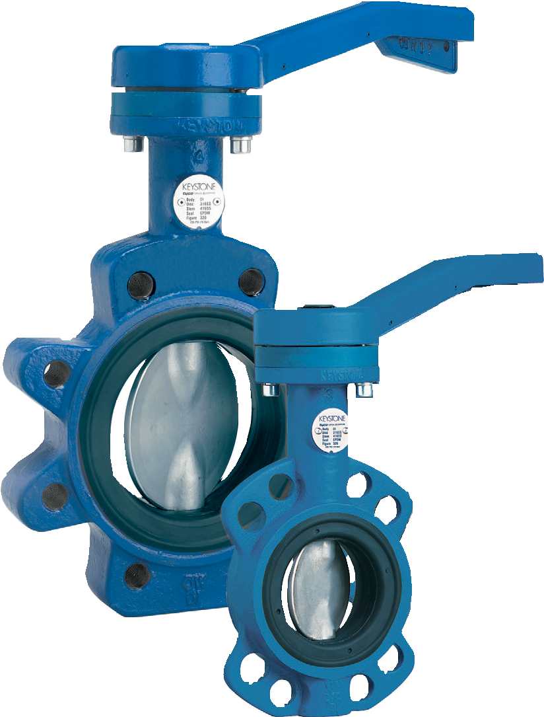
FEATURES
- Bubble-tight shut-off at full rating in both directions.
- One piece, specially profiled, wafer thin disc stem.
- Extended body neck allows free access to actuator where pipe insulation has been fitted.
- The seat and disc are the only two parts in contact with the medium.
- Face to face dimensions according
ISO 3202 Part 3, K1 (ISO 5752 series 20) and
DIN EN 558-1, series 20.
- The F320 wafer version has four flange locating holes for end of line service under certain conditions.
- Standard actuation:
  - Handle (F414) on DN 50-200 valves.
  - Gear operators (F455) on DN 250-300.
- The F322 lugged version is suitable for bi-directional end of line service.
- Suitable for pneumatic, electric and hydraulic actuation.

GENERAL APPLICATION

Figure 320/322 is designed for applications requiring shut-off control. The valve has a non-replaceable seat and can be used in
combination with manual or a gear operator, or any other common type of pneumatic, electric or hydraulic actuator.
TECHNICAL DATA

Size range: Figure 320 (wafer style)
DN 50-300
Figure 322 (lugged style) DN 50-300
Pressure: 16 bar (in line and end of line)
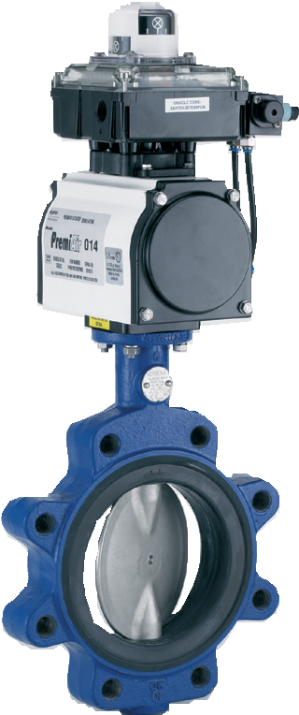
Temperature (°C): Minus 29°C to 120°C
(EPDM seat)
Minus 15°C to 100°C (NBR seat)

End connections | Between flanges | End of line
F320 | DN 50-300: PN 6-10-16  ASME 150 | DN 50-300: PN 16  ASME 150
 |  | DN 50-150: PN 10
F322 | DN 50-300: PN 6-10-16  ASME 150 | DN 50-300: PN 6-10-16  ASME 150

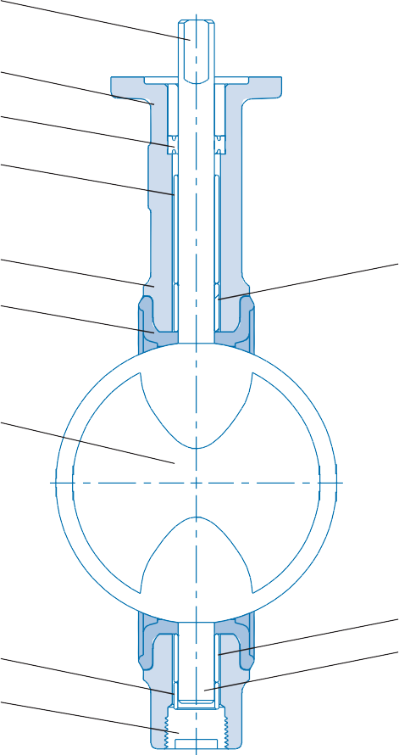
4

10

9

7

1 6
3

2

6
8 5
11

PART LIST
No. | Description | Material | Standard | Material number
1 | Body | Ductile iron | ASTM 536 Gr 65-45-12 | DIN 0.7040
2 | Disc | Stainless steel Aluminum bronze  Nickel aluminum bronze | ASTM A 351 Gr CF8M ASTM B 148 UNS C95200 A  BS EN 1982 CC 333 G | DIN 1.4408  DIN 2.0940.01  DIN 2.0975.01
3 | Seat | EPDM | - | -
 |  | NBR | - | -
4 | Top stem | 416 S/S | ASTM A 582, 416 cond. H | -
5 | Bottom stem | 416 S/S | ASTM A 582, 416 cond. H | -
6 | Bushing | Sintered bronze | ASTM B438 | -
7 | Upper spacer | - | - | -
8 | Lower spacer | - | - | -
9 | Packing | - | - | -
10 | Upper bushing | Thermoplastic polyester | ASTM D 4507 TPES 110M10 | A22310
11 | Plug | - | - | -

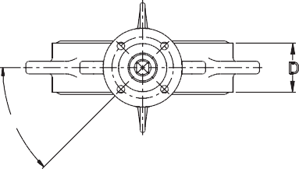
D
45?
G
F

H
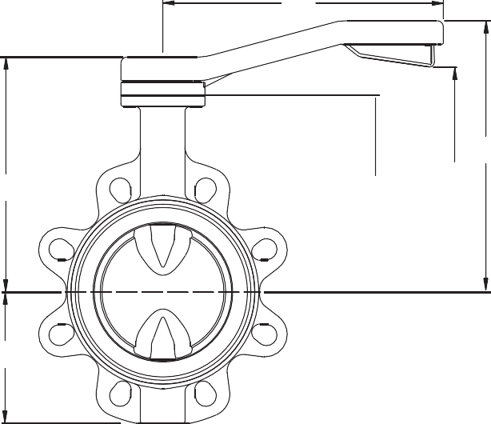
M
C2
C
E
C1
K
ØB
Figure 320 wafer
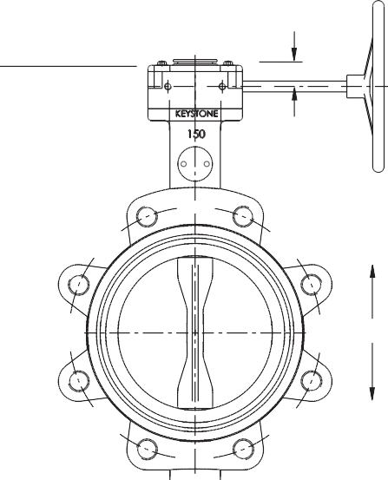Figure 322 lugged
M
R
ØN
C2
Q ØA ØYY
K
ØB1

DIMENSIONS (mm)
 |  |  |  |  |  |  |  |  | Stem connections |  |  |  |  |  |  |  |  |  | Mass kg*
Size | ØA | ØB | ØB1 | C | C1 | C2 | D | E | F | ØGh9 | H 0  -0.05 | ISO Type | K | M | ØN | Q | R | ØYY | F320 | F322 | Kv | fully open
50 | 52 | 98 | 157 | 172 | 147 | 197 | 43 | 135 | 25 | 12.00 | 8 | F05 | 78 | 230 |  | 31 |  | 87 | 3.7 | 4.4 | 108
65 | 64 | 116 | 177 | 194 | 180 | 230 | 46 | 150 | 30 | 15.88 | 11 | F07 | 83 | 300 |  | 47 |  | 98 | 5.9 | 6.5 | 217
80 | 77 | 126 | 192 | 204 | 190 | 240 | 46 | 160 | 30 | 15.88 | 11 | F07 | 91 | 300 |  | 63 |  | 114 | 6.4 | 7.6 | 409
100 | 103 | 156 | 225 | 224 | 110 | 260 | 52 | 180 | 30 | 15.88 | 11 | F07 | 105 | 300 |  | 90 |  | 146 | 7.9 | 9.7 | 807
125 | 128 | 182 | 254 | 239 | 225 | 275 | 56 | 195 | 30 | 20.00 | 14 | F07 | 127 | 300 |  | 116 |  | 168 | 9.4 | 12.7 | 1251
150 | 147 | 207 | 279 | 254 | 240 | 290 | 56 | 210 | 30 | 20.00 | 14 | F07 | 140 | 300 |  | 137 |  | 197 | 11.3 | 14.1 | 1946
200 | 198 | 264 | 336 | 240 |  | 311 | 60 | 240 | 30 | 20.00 | 14 | F07 | 174 | 327 | 300 | 190 | 37 | 258 | 26.1 | 30.2 | 3516
250 | 249 | 317 | 406 | 275 |  | 346 | 68 | 275 | 50 | 30.00 | 22 | F12 | 203 | 327 | 300 | 241 | 37 | 309 | 35.0 | 43.0 | 5806
300 | 300 | 373 | 476 | 310 |  | 381 | 78 | 310 | 50 | 30.00 | 22 | F12 | 235 | 327 | 300 | 291 | 37 | 354 | 46.1 | 55.4 | 8910

NOTES
Dimensions are nominal ± 1 mm.
- Q is the disc chordal dimension at face of valve for disc clearance into pipe fitting or equipment.
- Valves DN 50-200 are supplied standard with handles (F414).
Valves DN 250-300 are supplied standard with gear operators (F455).
- YY is outside diameter of seat face.
* The mass shown includes the standard operator.

ISO 5211 MOUNTING DETAILS
Type PCD Bolt holes
F05 50 4 x Ø7
F07 70 4 x Ø9
F12 125 4 x Ø14

ΔP in kPa | Size DN
 | 50 | 65 | 80 | 100 | 125 | 150 | 200 | 250 | 300

SIZING TORQUES (Nm)
I*
350 | 13 | 19 | 26 | 37 | 58 | 81 | 148 | 241 | 345
700 | 13 | 20 | 27 | 40 | 63 | 88 | 164 | 271 | 387
1000 | 14 | 21 | 30 | 44 | 70 | 99 | 188 | 315 | 451
1400 | 15 | 23 | 33 | 49 | 80 | 113 | 219 | 374 | 536
1600 | 15 | 24 | 35 | 51 | 85 | 120 | 235 | 403 | 578
II*
350 | 14 | 21 | 29 | 42 | 66 | 93 | 169 | 274 | 392
700 | 14 | 22 | 31 | 45 | 71 | 100 | 185 | 303 | 434
1000 | 15 | 23 | 33 | 49 | 78 | 111 | 208 | 347 | 498
1400 | 16 | 26 | 36 | 54 | 88 | 125 | 240 | 406 | 583
1600 | 17 | 27 | 38 | 56 | 93 | 132 | 255 | 435 | 625
III*
350 | 15 | 23 | 32 | 48 | 74 | 105 | 190 | 306 | 439
700 | 16 | 24 | 34 | 50 | 79 | 112 | 206 | 336 | 481
1000 | 16 | 26 | 36 | 54 | 86 | 122 | 229 | 380 | 545
1400 | 17 | 28 | 40 | 59 | 96 | 136 | 261 | 439 | 629
1600 | 18 | 29 | 41 | 61 | 101 | 143 | 276 | 468 | 672
* Application I, II, III

NOTES
- Application I: Water, seawater, lubricating types of hydrocarbons. Temp.: 0-80°C; valve opens at least once a month.
Application II: All other liquid applications and lubricating gasses.
Application III: Non lubricating and dry media.
- The charted maximum sizing operating torque is the sum of all friction and resistance for opening and closing of the disc against the indicated pressure differential.
- The effect of dynamic torque is not considered in tabulation.
- In sizing operators it is not necessary to include safety-factors.
- Rated Kv = the volume of water in m3/hr that will pass through a given valve opening at a pressure drop of 1 bar.

TRIM CODES MAXIMUM ALLOWABLE SHAFT TORQUES (Nm)
Figure no. | Trim Code | Body | Disc | Shaft | Seat |  | Size DN | Torques
F320/322 | 112 | Ductile iron | S/S | S/S | EPDM |  | 50 | 75
F320/322 | 116 | Ductile iron | S/S | S/S | NBR |  | 65 | 184
F320/322 | 135 | Ductile iron | NiAlBz | S/S | EPDM |  | 80 | 184
F320/322 | 137 | Ductile iron | NiAlBz | S/S | NBR |  | 100 | 184
F320/322 | 333 | Ductile iron | AlBz | S/S | EPDM |  | 125 | 374
F320/322 | 334 | Ductile iron | AlBz | S/S | NBR |  | 150 | 374
 |  |  |  |  |  |  | 200 | 374
 |  |  |  |  |  |  | 250 | 1353
 |  |  |  |  |  |  | 300 | 1353

Neither Emerson, Emerson Automation Solutions, nor any of their affiliated entities assumes responsibility for the selection, use or maintenance of any product. Responsibility for proper selection, use, and maintenance of any product remains solely with the purchaser and end user.

Keystone is a mark owned by one of the companies in the Emerson Automation Solutions business unit of Emerson Electric Co. Emerson Automation Solutions, Emerson and the Emerson logo are trademarks and service marks of Emerson Electric Co. All other marks are the property of their respective owners.

The contents of this publication are presented for informational purposes only, and while every effort has been made to ensure their accuracy, they are not to be construed as warranties or guarantees, express or implied, regarding the products or services described herein or their use or applicability. All sales are governed by our terms and conditions, which are available upon request. We reserve the right to modify or improve the designs or specifications of such products at any time without notice.

Emerson.com/FinalControl

