KEYSTONE F89 PNEUMATIC QUARTER-TURN ACTUATOR

GENERAL PURPOSE / HAZARDOUS AREA

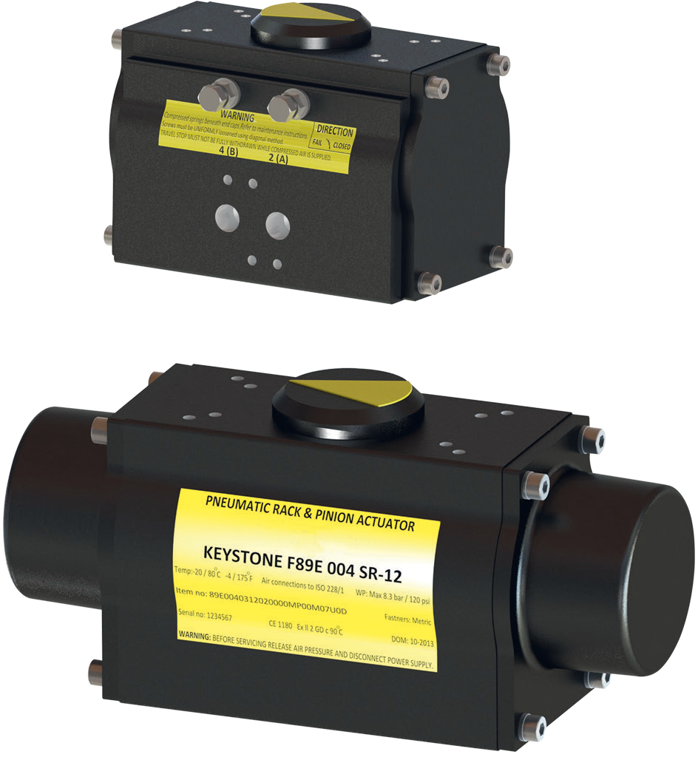
FEATURES
- Direct mounting to all Keystone butterfly valves and ball valves.
- Valve connection compatible with Keystone (imperial and metric) and ISO 5211.
- Double Rack and Pinion design nullifies side loads on the pinion shaft, minimizing bearing wear and extending life.
- Optimized product flow with standard mounted travel stops for valve position adjustment in open and close position (+/- 5° at each end).
- Anodized aluminium body with electrostatic powder coating (ESPC) finish provides durable protection against corrosive environments.
- Double acting and spring return versions available for cost effective and safe operation.
- Up to 12 individual springs offer flexible torque range for both ball as butterfly valves.
- Pre-compressed spring design and anti-blowout drive pinion means safe maintenance and operation.

MATERIALS

Body: Extruded aluminium (ESPC coated) End caps: Cast aluminium (ESPC coated)

MOUNTING SPECIFICATIONS

Actuator to valve: ISO and Keystone standard Accessories: Namur VDI/VDE 3845

PERFORMANCE DATA

The F89 actuator meets the EN15714-3 requirements and has been validated for a lifetime up to 500,000 cycles under the specified conditions.

TECHNICAL DATA

Torque output range:
Double acting: 11 - 4173 Nm (97 - 36955 in·lb)
Spring return: 6 - 1663 Nm (51 - 14729 in·lb)
Operating medium: Compressed air
(dry or lubricated)
Air supply pressure: 8.3 bar (120 psi) max. dynamic
10 bar (145 psi) max. static Travel adjustment: +/- 5° at each end of travel
0-100% travel stop available on request
Temperature range: -20°C to +80°C
(-4°F to +176°F)
Low temp version: -52°C to +65°C
(-62°F to +149°F)
High temp version: -15°C to +150°C
(5°F to +302°F)
Certification: ATEX II 2 GD IIC T6

PRINCIPLE OF OPERATION

Both the double acting and spring return actuators feature a compact design each with their own set of end caps. The unit can be converted from double acting to single acting (or reverse) in the field without the requirement of special tools. The spring return actuator is available with spring sets representing 2.8 bar (40 psi) to 8.3 bar (120 psi) in 0.7 bar (10 psi) increments.
The springs are manufactured from heavy gauge wire to assure long life and ESPC coated for corrosion resistance. They are pre-compressed using a special container to ensure safe operation and maintenance.

DOUBLE ACTING
To open valve
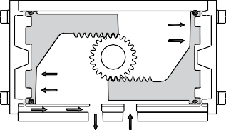
In a double acting application, air pressure is introduced to Port 2 (A), pressurizing the space between the pistons and driving the pistons out towards the actuator ends. The volume
of air above the piston heads is exhausted to atmosphere. This causes the piston racks to drive the pinion in a counterclockwise direction,

The dual-keyed output shaft allows parallel or perpendicular mounting to the valve flow direction. In normal conditions the actuator is mounted in parallel with the valve flow direction, operating in a counter clockwise (CCW) rotation from the closed to the open position.

The standard operation direction of the spring fail close action is clockwise (CW). By rotating the pistons 180 degrees in the body in relation to the pinion, the actuator operation direction can be reversed. Although rotating the actuator 90 degrees will have a similar effect, the piston rotation is preferred as it maintains the parallel mounting and keeps the valve operation in
the correct quadrant.

resulting in a quarterturn rotation. This rotation is transferred to the valve shaft, opening the valve.

To close valve
Air pressure introduced to Port 4 (B), pressurizes the spaces above each piston head and drives the pistons inward. The volume
of air between the pistons is exhausted to atmosphere. This causes the piston racks to drive the pinion in a clockwise direction, resulting in a quarter-turn rotation.
This rotation is transferred to the valve shaft, closing the valve.
4 (B) 2 (A)
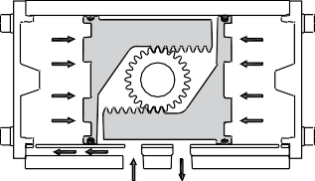
Exhaust Air in

4 (B) 2 (A)
Air in Exhaust

SPRING RETURN
To open valve
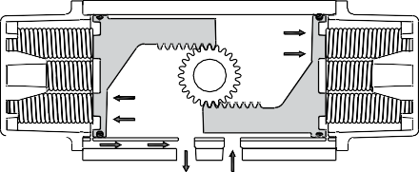
In a single acting application, air pressure is introduced to Port 2 (A), pressurizing the space between the pistons and driving the pistons out towards the actuator ends while at the same
time compressing the springs. This causes the piston racks to drive the pinion
in a counterclockwise direction, resulting in a quarter-turn rotation. This rotation is
transferred to the valve shaft, opening the valve.

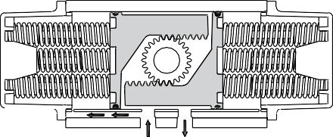
To close valve
When the air pressure is relieved, the spring tension moves the pistons inward and exhausts the air through Port 2 (A). This causes the piston racks to drive the pinion in a clockwise
direction, resulting in a quarter-turn rotation. This rotation is transferred to the valve shaft,
closing the valve.

4 (B) 2 (A)
Vent port Air in

4 (B) 2 (A)
Vent port Exhaust

TRAVEL ADJUSTMENT
Within the mechanical connections of the drive between the valve and the actuator there are several points of manufacturing tolerance, including valve disc or ball to stem, stem to adapter, and adapter to actuator that must
be compensated for in the operation of the assembly. Therefore, adjustment is necessary to ensure that valve operation is as precise as required. The F89 dual travel stops allow +/-5° adjustment at both ends of the stroke, resulting in a total stroke range of 80° to 100° rotation. For special applications an optional linear travel stop is available, which reduces
the stroke from 0-100%.

Resilient seated butterfly valves
Shut-off occurs before the disc has rotated a full 90° from the open position. Travel adjustment is therefore desirable to prevent over travel, which would result in
unnecessary operating torque and premature deterioration of seat life. In the open position, adjustment is necessary to ensure maximum flow through the valve and minimum dynamic forces acting on the disc.

High performance butterfly valves
The double offset design of high performance butterfly valves results in the disc moving into the seat with a camming action. It is important that the disc does not travel beyond the seat position, otherwise damage to the seat will occur.

Ball and plug valves
The ball or plug must be precisely in line with the valve port to prevent damage to the seat in the open position. Adjustment at the closed position is necessary to ensure that complete shut-off is achieved.

DIMENSIONS

Top view model 002 – 020
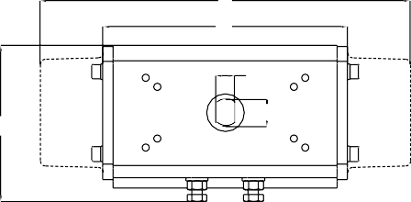
A1
A2
C
H
J

Side view
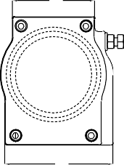
D
E

TABLE 1 - DIMENSIONS F89 METRIC (mm)

Top view model 032 – 240
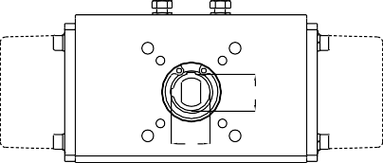
H
J

Front view

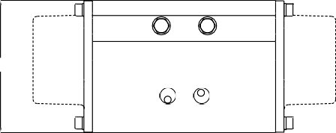
B

Model  F89-002 | A1 (1)  - | A2 (1)  121 | B  72 | C  74 | D  54 | E  66 | Top of shaft (2)
 |  |  |  |  |  |  | H | J Key
 |  |  |  |  |  |  | 16.0 | 11.0
F89-003 | 186 | 125 | 86 | 81 | 59 | 79 | 16.0 | 11.0
F89-004 | 217 | 143 | 96 | 91 | 61 | 80 | 16.0 | 11.0
F89-006 | 259 | 169 | 101 | 108 | 64 | 87 | 16.0 | 11.0
F89-009 | 257 | 174 | 119 | 124 | 64 | 99 | 16.0 | 11.0
F89-014 | 307 | 193 | 138 | 141 | 78 | 112 | 16.0 | 11.0
F89-020 | 378 | 236 | 155 | 157 | 81 | 123 | 16.0 | 11.0
F89-032/033 | 462 | 283 | 171 | 182 | 95 | 136 | 20.6 | 21.6 | 4.8
F89-051/052 | 476 | 298 | 213 | 210 | 111 | 159 | 20.6 | 21.6 | 4.8
F89-084/085/086 | 627 | 384 | 227 | 233 | 130 | 190 | 25.4 | 27.0 | 6.4
F89-139/140/141 | 726 | 431 | 274 | 288 | 154 | 233 | 25.4 | 27.0 | 6.4
F89-240 | 845 | 507 | 325 | 341 | 186 | 290 | 25.4 | 27.0 | 6.4

TABLE 2 - DIMENSIONS F89 IMPERIAL (in)
Model  F89-002 | A1 (1)  - | A2 (1)  4.76 | B  2.83 | C  2.91 | D  2.13 | E  2.60 | Top of shaft (2)
 |  |  |  |  |  |  | H | J Key
 |  |  |  |  |  |  | ⅝ | 7/16
F89-003 | 7.30 | 4.90 | 3.39 | 3.18 | 2.32 | 3.09 | ⅝ | 7/16
F89-004 | 8.53 | 5.63 | 3.78 | 3.60 | 2.40 | 3.15 | ⅝ | 7/16
F89-006 | 10.20 | 6.65 | 3.97 | 4.26 | 2.52 | 3.42 | ⅝ | 7/16
F89-009 | 10.10 | 6.85 | 4.69 | 4.87 | 2.52 | 3.91 | ⅝ | 7/16
F89-014 | 12.07 | 7.60 | 5.42 | 5.55 | 3.07 | 4.41 | ⅝ | 7/16
F89-020 | 14.89 | 9.29 | 6.10 | 6.20 | 3.19 | 4.82 | ⅝ | 7/16
F89-032/033 | 18.20 | 11.14 | 6.73 | 7.18 | 3.74 | 5.35 | 0.81 | 0.84 | 0.19
F89-051/052 | 18.72 | 11.73 | 8.37 | 8.25 | 4.37 | 6.26 | 0.81 | 0.84 | 0.19
F89-084/085/086 | 24.69 | 15.12 | 8.94 | 9.17 | 5.12 | 7.48 | 1.00 | 1.06 | 0.25
F89-139/140/141 | 28.58 | 16.97 | 10.79 | 11.34 | 6.06 | 9.17 | 1.00 | 1.06 | 0.25
F89-240 | 33.27 | 19.96 | 12.80 | 13.43 | 7.32 | 11.42 | 1.00 | 1.06 | 0.25

NOTES
- A1 = spring return; A2 = double acting
- All actuators have either DD 16.0 x 11.0 (DD ⅝ x 7/16) top shaft connection or a plastic insert to this dimension, for direct mounting of switchbox accessories. Indicated values are actual pinion top dimensions.

DIMENSIONS
Pinion connection F89E sizes 002-020 Pinion connection F89E sizes 032-240
G
F
K
Ø F

The F89 actuator is available with 4 different valve connections: F89D - ISO 5211 (metric threaded); F89E - Keystone ISO (metric threaded); F89U - Keystone imperial + metric threaded

TABLE 3A - VALVE CONNECTION ISO FLANGE (mm)
Model  F89-002 | F89E - Keystone ISO F89D - ISO 5211
 | F | Bottom of shaft  G Key PCD |  |  | Mounting holes  No x Size x Depth | Bottom of shaft  Drive: Star no | PCD | Mounting holes  No x Size x Depth
 | 16.0 | 11.0 |  | F03  F05 | 4x M5 x 8.0  4x M6 x 10.0 | ** | F03  F05 | 4x M5 x 8.0  4x M6 x 10.0
F89-003 | 16.0 | 11.0 |  | F05  F07 | 4x M6 x 10.0  4x M8 x 13.0 | 14 | F05  F07 | 4x M6 x 10.0  4x M8 x 13.0
F89-004 | 16.0 | 11.0 |  | F05  F07 | 4x M6 x 10.0  4x M8 x 13.0 | 14 | F05  F07 | 4x M6 x 10.0  4x M8 x 13.0
F89-006 | 20.0 | 14.0 |  | F05  F07 | 4x M6 x 10.0  4x M8 x 13.0 | 17 | F05  F07 | 4x M6 x 10.0  4x M8 x 13.0
F89-009 | 20.0 | 14.0 |  | F05  F07 | 4x M6 x 10.0  4x M8 x 13.0 | 17 | F05  F07 | 4x M6 x 10.0  4x M8 x 13.0
F89-014 | 20.0 | 14.0 |  | F07 | 4x M8 x 13.0 | 17 | F07 | 4x M8 x 13.0
F89-020 | 25.0 | 18.0 |  | F07 F10  F12 | 4x M8 x 13.0  4x M10 x 15.0  4x M12 x 19.0 | 22 | F07 F10  F12 | 4x M8 x 13.0  4x M10 x 15.0  4x M12 x 19.0
F89-032 | 35.0 10 x 8 |  |  | F10  F12 | 4x M10 x 15.0  4x M12 x 19.0 | 27 | F10  F12 | 4x M10 x 15.0  4x M12 x 19.0
F89-052 | 35.0 10 x 8 |  |  | F10  F12 | 4x M10 x 15.0  4x M12 x 19.0 | 27 | F10  F12 | 4x M10 x 15.0  4x M12 x 19.0
F89-084* | 50.0 14 x 9 |  |  | F10  F14 | 4x M10 x 15.0  4x M16 x 24.0 | 36 | F10  F14 | 4x M10 x 15.0  4x M16 x 24.0
F89-085 | 50.0 14 x 9 |  |  | F12  F16 | 4x M12 x 19.0  4x M20 x 30.0 | 36 | F12  F16 | 4x M12 x 19.0  4x M20 x 30.0
F89-139 | 45.0 14 x 9 |  |  | F14 | 4x M16 x 24.0
F89-140 | 50.0 14 x 9 |  |  | F14 | 4x M16 x 24.0 | 46 | F14 | 4x M16 x 24.0
F89-141 | 50.0 14 x 9 |  |  | F12  F16 | 4x M12 x 19.0  4x M20 x 30.0 | 46 | F12  F16 | 4x M12 x 19.0  4x M20 x 30.0
F89-240 | 70.0 |  | 20 x 12 | F16  F25 | 4x M20 x 30.0  8x M16 x 24.0 | 46 | F16  F25 | 4x M20 x 30.0  8x M16 x 24.0

NOTES
F89-084 is identical to F89-085 with F10-F14 flange F89-140 is identical to F89-141 with F14 flange
* F89-084: F10 drilling not in body; please use optional F10 to F14 conversion plate
** Square 14 at 45 degrees

DIMENSIONS
Pinion connection F89U sizes 002-003 Pinion connection F89U sizes 004-240
G
F
K
Ø F

TABLE 3B - VALVE CONNECTION KEYSTONE FLANGE
Model  F89-002 | F89U - Keystone metric (mm) F89U - Keystone imperial (in) |  |  |  |  |  |  |  |  |  | Code*
 | F | Bottom of shaft  G Key |  | PCD | Mounting holes  No x Size x Depth | F | Bottom of shaft  G Key |  | PCD | Mounting holes  No x Size x Depth
 | ** |  |  | 44.5 | 4x M6 x 8.0 | *** |  |  | 1¾ | 4x ¼-20 UNC x 0.38
F89-003 | 19.0 | 12.7 |  | 44.5  82.5 | 4x M6 x 10.0  4x M10 x 15.0 | ¾ | ½ |  | 1¾  3¼ | 4x ¼-20 UNC x 0.38  4x ⅜-16 UNC x 0.56 | AAA  BAD
F89-004 | 20.6 |  | 4.8 x 4.8 | 44.5  82.5 | 4x M6 x 10.0  4x M10 x 15.0 | 13/16 |  | 3/16 x 3/16 | 1¾  3¼ | 4x ¼-20 UNC x 0.38  4x ⅜-16 UNC x 0.56 | AAA  BAC
F89-006 | 25.4 |  | 6.4 x 6.4 | 82.5 | 4x M10 x 15.0 | 1 |  | ¼ x ¼ | 3¼ | 4x ⅜-16 UNC x 0.56 | BAD
F89-009 | 25.4 |  | 6.4 x 6.4 | 82.5 | 4x M10 x 15.0 | 1 |  | ¼ x ¼ | 3¼ | 4x ⅜-16 UNC x 0.56 | BAD
F89-014 | 25.4 |  | 6.4 x 6.4 | 82.5 | 4x M10 x 15.0 | 1 |  | ¼ x ¼ | 3¼ | 4x ⅜-16 UNC x 0.56 | BAD
F89-020 | 28.6 |  | 6.4 x 6.4 | 82.5  127.0 | 4x M10 x 15.0  4x M12 x 19.0 | 1⅛ |  | ¼ x ¼ | 3¼  5 | 4x ⅜-16 UNC x 0.56  4x ½-13 UNC x 0.63 | BAD  CAF
F89-032 | 28.6 |  | 6.4 x 6.4 | 82.5  127.0 | 4x M10 x 15.0  4x M12 x 19.0 | 1⅛ |  | ¼ x ¼ | 3¼  5 | 4x ⅜-16 UNC x 0.56  4x ½-13 UNC x 0.63 | BAD  CAF
F89-033 | 34.9 |  | 7.9 x 7.9 | 82.5  127.0 | 4x M10 x 15.0  4x M12 x 19.0 | 1⅜ |  | 5/16 x 5/16 | 3¼  5 | 4x ⅜-16 UNC x 0.56  4x ½-13 UNC x 0.63 | BAD  CAG
F89-051 | 28.6 |  | 6.4 x 6.4 | 82.5  127.0 | 4x M10 x 15.0  4x M12 x 19.0 | 1⅛ |  | ¼ x ¼ | 3¼  5 | 4x ⅜-16 UNC x 0.56  4x ½-13 UNC x 0.63 | BAD  CAF
F89-052 | 34.9 |  | 7.9 x 7.9 | 82.5  127.0 | 4x M10 x 15.0  4x M12 x 19.0 | 1⅜ |  | 5/16 x 5/16 | 3¼  5 | 4x ⅜-16 UNC x 0.56  4x ½-13 UNC x 0.63 | BAD  CAG
F89-085 | 41.3 |  | 9.5 x 9.5 | 127.0  165.0 | 4x M12 x 19.0  4x M20 x 30.0 | 1⅝ |  | ⅜ x ⅜ | 5  6½ | 4x ½-13 UNC x 0.63  4x ¾-10 UNC x 1.00 | CAH  DAH
F89-086 | 47.6 |  | 12.7 x 9.5 | 127.0  165.0 | 4x M12 x 19.0  4x M20 x 30.0 | 1⅞ |  | ½ x ⅜ | 5  6½ | 4x ½-13 UNC x 0.63  4x ¾-10 UNC x 1.00 | CAJ  DAJ
F89-140 | 57.2 |  | 12.7 x 9.5 | 127.0  165.0 | 4x M12 x 19.0  4x M20 x 30.0 | 2¼ |  | ½ x ⅜ | 5  6½ | 4x ½-13 UNC x 0.63  4x ¾-10 UNC x 1.00 | CAK  DAK
F89-240 | 57.2 |  | 12.7 x 9.5 | 165.0 | 4x M20 x 30.0 | 2¼ |  | ½ x ⅜ | 6½ | 4x ¾-10 UNC x 1.00 | DAK

NOTES
F89-033 is identical to F89-032 with larger bore F89-051 is identical to F89-052 with smaller bore F89-084 is identical to F89-085 with smaller bore F89-086 is identical to F89-085 with larger bore
* Keystone mounting compatibility code
** Square 14 at 45 degrees
*** Square 0.55 at 45 degrees

TOP MOUNT DRILLING
The top mount drilling is available with metric or imperial threading. The dimensions of the hole pattern are identical.

30 (1.18) 41.1 (1.62)

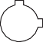93.5 (3.68)
H
J
130.0 (5.12)

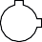Top mounting drilling sizes 002 - 020 Top mounting drilling sizes 032 - 052 Top mounting drilling sizes 084 - 240
H
30 (1.18) 41.1 (1.62)
J

80 (3.15)
93.5 (3.68)
H
30 (1.18) 41.1 (1.62)
J

80 (3.15)
93.5 (3.68)

NOTES
- For model 002/003 the Keystone drilling pattern (93.5x41.1mm) exceeds the body dimensions. Please add Keystone mounting plate option (item 11425095).
- Metric threaded versions have a bolt threading of M5x1.0 x 10.0 mm deep.
- Imperial threaded versions have a bolt threading of 10-32 UNF x 0.28 inch deep.

NAMUR VDI/VDE 3845 MOUNTING
Full adoption to the VDI/VDE 3845 standard can be achieved with the introduction of a male insert into the female shaft.

4.0
(0.16)
(0.79) (0.16)
20.0
4.0

Ø 16.0
(0.63)
M6 x 0.47

11.0 (0.43) A/F

AIR CONNECTION
The actuator is controlled by applying compressed air to the ¼” BSP/NPT ports (½” BSP/NPT for Model F89-240), or with a Namur solenoid valve.

B port

¼" BSP/NPT

A port

12 (0.47)

32 (1.26)

¼" BSP/NPT 24 (0.95)

A port

20
(0.79)
45 (1.77)

½" BSP/NPT

40 (1.58)

B port
16 (0.63)
B port
22.5 (0.89)

Air connection sizes 002 - 052 Air connection sizes 085 - 140 Air connection size 240
A port
32 (1.26)

16 (0.63)
12 (0.47)
24 (0.95)

NOTES
- Metric threaded versions have a bolt threading of M5x1.0 x 10.0 mm deep.
- Imperial threaded versions have a bolt threading of 10-32 UNF x 0.28 inch deep.
- F89D has BSP air connections only

ACTUATOR PISTON DISPLACEMENT

Piston displacement is the total volume of pressurized air after the actuator has completed its stroke.

TABLE 4 - ACTUATOR VOLUME
NOTES
Air consumption calculation: volume in table represents actual free air volume in either open or close direction.
Air consumption will vary depending on supply pressure. To determine air consumption per minute

 |  | Opening |  |  | Closing |  | use the following formula:
Model | litres |  | cu.in | litres |  | cu.in
F89-002 | 0.11 |  | 6.7 | 0.09 |  | 5.5 | Double acting (nL/min):
F89-003 | 0.17 |  | 10.4 | 0.14 |  | 8.5 | Open + Supply
F89-004 | 0.25 | 15.3 |  | 0.21 | 12.8 |  | Close volume (l) |  | air pressure + 1 | Cycles/
F89-006 | 0.36 | 21.8 |  | 0.29 | 17.7 |  | 1 |  | 1 | Min
F89-009 | 0.57 | 34.9 |  | 0.48 | 29.3 |  | Double acting (SCFM):

F89-014 0.90 54.9
F89-020 1.37 83.8
F89-032/033 2.10 128.2
F89-051/052 3.10 189.2
F89-084/085/086 5.09 310.6
F89-139/140/141 8.92 544.3
F89-240 15.40 939.8
0.73 44.5
1.08 65.9
1.66 101.3
2.63 160.5
3.87 236.2
6.81 415.6
12.63 770.7

Cycles/ Min

TABLE 5 - ACTUATOR CYCLING TIME (s)
Close volume (in3)
Open +
Supply
172) 8
air pressure + 14.7
14.7
Model | DA |  |  |  |  |  |  | SR
 | Travel  Opening | time  Closing |  | Total time  Opening | Closing | Travel time  Opening Closing |  | Total time  Opening Closing
F89-002 | 0.1 | 0.0 | 0.1 |  | 0.0
F89-003 | 0.1 | 0.1 | 0.1 |  | 0.1 | 0.1 | 0.1 |  | 0.1 | 0.1
F89-004 | 0.1 | 0.1 | 0.1 |  | 0.1 | 0.1 | 0.1 |  | 0.1 | 0.1
F89-006 | 0.1 | 0.1 | 0.1 |  | 0.1 | 0.1 | 0.1 |  | 0.1 | 0.1
F89-009 | 0.2 | 0.2 | 0.2 |  | 0.2 | 0.2 | 0.2 |  | 0.2 | 0.2
F89-014 | 0.3 | 0.2 | 0.3 |  | 0.3 | 0.4 | 0.2 |  | 0.5 | 0.2
F89-020 | 0.4 | 0.3 | 0.5 |  | 0.4 | 0.9 | 0.3 |  | 1.0 | 0.4
F89-032/033 | 0.5 | 0.5 | 0.7 |  | 0.6 | 1.0 | 0.5 |  | 1.2 | 0.7
F89-051/052 | 0.8 | 0.7 | 1.1 |  | 0.9 | 1.2 | 0.7 |  | 1.5 | 0.9
F89-084/085/086 | 0.8 | 0.8 | 1.8 |  | 1.7 | 1.9 | 0.6 |  | 3.0 | 1.1
F89-139/140/141 | 1.4 | 1.5 | 3.1 |  | 2.9 | 3.2 | 1.1 |  | 5.0 | 1.8
F89-240 | 2.9 | 3.4 | 6.5 |  | 6.0 | 6.1 | 4.1 |  | 9.7 | 6.9

NOTES
- The actuator stroke time consist of the time required to build up pressure in the actuator and consequently move the pistons and valve (=travel time). The sum of these values is the total cycling time.
- The actuator stroke time varies with the supplied air pressure, solenoid valve, and required valve torque, and are for indication only.
- Speed reduction on inlet or exhaust ports will improve actuator endurance and are required to meet the lifetime as per EN15714-3 standard.
- Indicated stroke times above are based on a bare actuator using 5.5 bar (80 psi) air pressure and a solenoid valve with Cv of 1300 l/m (46 CFM).

TABLE 6 - ACTUATOR WEIGHT
 |  | DA |  |  | SR
Model | kg |  | lbs | kg |  | lbs
F89-002 | 1.0 |  | 2.2 | - |  | -
F89-003 | 1.4 |  | 3.1 | 1.7 |  | 3.7
F89-004 | 2.1 |  | 4.6 | 2.6 |  | 5.7
F89-006 | 2.9 |  | 6.4 | 3.6 |  | 7.9
F89-009 | 3.7 |  | 8.2 | 4.9 |  | 10.8
F89-014 | 5.3 |  | 11.7 | 7.3 |  | 16.1
F89-020 | 7.9 |  | 17.4 | 11.0 |  | 24.3
F89-032/033 | 12.1 |  | 26.7 | 16.7 |  | 36.8
F89-051/052 | 18.3 |  | 40.3 | 24.9 |  | 54.9
F89-084/085/086 | 27.8 |  | 61.3 | 39.7 |  | 87.5
F89-139/140/141 | 45.8 |  | 101.0 | 69.5 |  | 153.2
F89-240 | 77.5 |  | 170.9 | 112.4 |  | 247.8

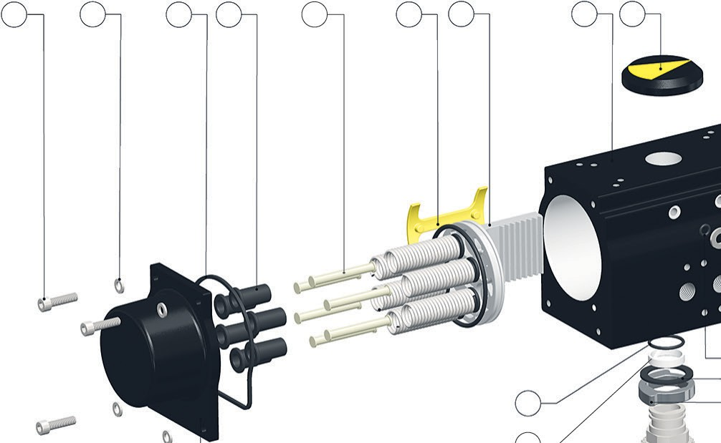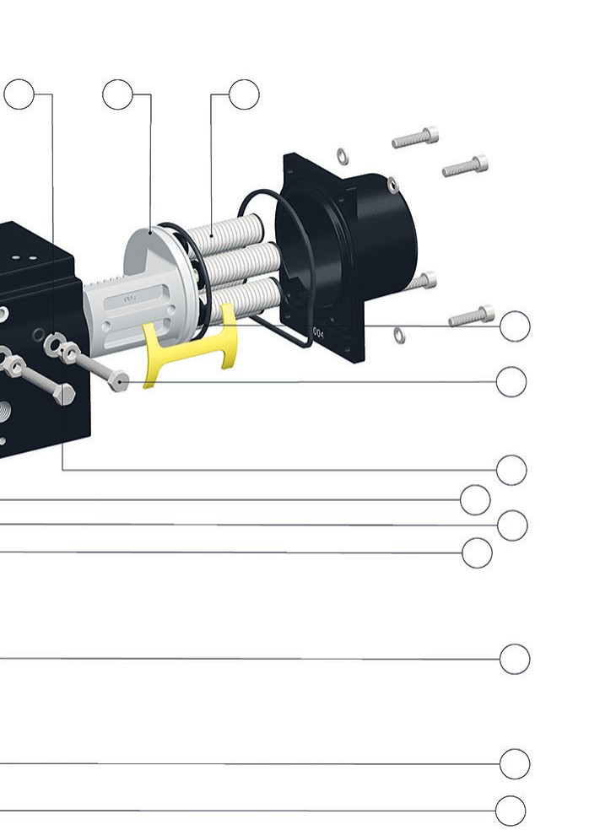MATERIALS OF CONSTRUCTION

22 15 20 8 7 9 3 1 25 14 3 6

18

21

23
19
12
16 5

10

4 2

11
17
13
24

TABLE 7 - MATERIALS OF CONSTRUCTION
No. | Item | Material | US material std | BS material std | DIN material std | Finish
1 | Body | Extruded aluminium  ASTM B221 type 6063T6 | ASTM B221 | BS 1474 6063 | DIN 3.33206.51 | Anodized 5-8 microns +  ESPC 60-80 microns
2 | Pinion | Hot rolled carbon steel bar  ASTM A108 grade 1045 | A108 | BS 970 080M40 | C40 | Zink-Nickel plated  8-12 microns
3 | Piston | Die cast aluminium alloy ASTM B85 type A380 /BS 1490  grade LM24 | ASTM B85 | BS 1490 | DIN 1725-2300 or 226 | Anodized
4 | End cap | Die cast aluminium alloy ASTM B85 type A380/BS 1490  grade LM24 | ASTM B85 | BS 1490 | DIN 1725-2300 or 226 | ESPC 60-80 microns
5 | Cam | Cast grade SAE 1045/C45 / EN8 |  |  |  | Blackodised
6 | Spring | Spring steel as per ASTM A401 | ASTM A401 | BS 5216 HS3 | DIN 17223 Pti | Epoxy coated 30-40 microns
7 | Spring retainer | Carbon steel |  |  |  | Zinc plated
8 | Spring cup | Die cast aluminium alloy ASTM B85 type A380 /BS 1490 grade  LM24 (PA66 up to model 052) | ASTM B85 | BS 1490 | DIN1725-2300 or 226 | Anodized
9 | Piston guide | Zytel 101F NC010 |  |  |  | Natural
10 | Top bearing | PAR (1) + 25% glass filled |  |  |  | Natural
11 | Bottom bearing | PAR (1) + 25% glass filled |  |  |  | Natural
12 | Top thrust washer | PA66 (2) |  |  |  | Natural
13 | Bottom thrust washer | PA66 (2) |  |  |  | Natural
14 | Travel stop washer | SS (3) ISO 3506 A2-70 grade |  |  |  | Natural
15 | End cap washer (spring  washer) | SS (3) ISO 3506 A2-70 grade |  |  |  | Natural
16 | Top O-ring (pinion) | NBR shore 70 A |  |  |  | Natural
17 | Bottom O-ring (pinion) | NBR shore 70 A |  |  |  | Natural
18 | O-ring (piston) | NBR shore 70 A |  |  |  | Natural
19 | O-ring (travel stop) | NBR shore 70 A |  |  |  | Natural
20 | Gasket (end cap) | NBR shore 70 A |  |  |  | Natural
21 | Bolt - travel stop | SS (3) ISO 3506 A2-70 grade |  |  |  | Natural
22 | Bolt - end cap | SS (3) ISO 3506 A2-70 grade |  |  |  | Natural
23 | Nut - travel stop | SS (3) ISO 3506 A2-70 grade |  |  |  | Natural
24 | Circlip (bottom) | Carbon steel |  |  |  | Zink-Nickel plated
25 | Position indicator | ABS plastic |  |  |  | Natural
1. POM Acetal Resin 2. Polyamide grade 66 3. Stainless steel

TORQUE OUTPUT
Double acting actuator
For sizing of double acting actuators use the following table and select the actuator
which will provide nearest torque output above the anticipated torque of the valve and required safety factor.

TABLE 8 - DA TORQUE (Nm)
F89-002 | 11 | 15 | 18 | 20 | 22 | 25 | 30 |  | F89-002 100 | 134 | 167 | 184 | 201 | 234 | 277
F89-003 | 17 | 22 | 28 | 31 | 33 | 39 | 46 |  | F89-003 147 | 197 | 246 | 270 | 295 | 344 | 408
F89-004 | 25 | 34 | 42 | 46 | 50 | 59 | 70 |  | F89-004 223 | 297 | 372 | 409 | 446 | 521 | 617
F89-006 | 36 | 48 | 60 | 66 | 72 | 84 | 100 |  | F89-006 320 | 427 | 534 | 587 | 641 | 747 | 886
F89-009 | 58 | 77 | 96 | 106 | 116 | 135 | 160 |  | F89-009 512 | 683 | 853 | 938 | 1024 | 1194 | 1416
F89-014 | 90 | 121 | 151 | 166 | 181 | 211 | 250 |  | F89-014 801 | 1068 | 1334 | 1468 | 1601 | 1868 | 2215
F89-020 | 132 | 177 | 221 | 243 | 265 | 309 | 366 |  | F89-020 1173 | 1563 | 1954 | 2150 | 2345 | 2736 | 3244
F89-032/033 | 208 | 277 | 346 | 381 | 416 | 485 | 575 |  | F89-032/033 1841 | 2455 | 3068 | 3375 | 3682 | 4295 | 5093
F89-051/052 | 315 | 420 | 525 | 577 | 630 | 735 | 871 |  | F89-051/052 2789 | 3718 | 4648 | 5112 | 5577 | 6507 | 7715
F89-084/085/086 | 525 | 701 | 876 | 963 | 1051 | 1226 | 1454 |  | F89-084/085 4652 | 6203 | 7754 | 8529 | 9304 | 10855 | 12871
F89-139/140/141 | 913 | 1218 | 1522 | 1674 | 1826 | 2131 | 2527 |  | F89-140/141 7749 | 10332 | 12915 | 14206 | 15497 | 18080 | 21438
F89-240 | 1508 | 2011 | 2514 | 2765 | 3017 | 3520 | 4173 |  | F89-240 13357 | 17810 | 22262 | 24489 | 26715 | 31167 | 36955

Model | Air pressure (bar)
 | 3 | 4 | 5 | 5.5 | 6 | 7 | 8.3

Spring return actuator
Sizing of spring return actuators is more complex. First you need to determine
the desired 'failure mode' (fail open or fail closed). Secondly you need to determine
the critical torque points for the subject valve using the table below.

TABLE 9 - DA TORQUE (in·lb)
Model | Air pressure (psi)
 | 40 | 60 | 70 | 80 | 90 | 100 | 120

Butterfly valves 'fail closed' Butterfly valves 'fail open'
Start of air torque
End of spring torque
Start of spring torque
End of air torque
Ball valves 'fail closed' Ball valves 'fail open'
Start of air (unseating) torque Start of spring (unseating) torque
End of air (full open) torque End of spring (full open) torque
Start of spring (breakout from open) torque Start of air (breakout from open) torque End of spring (re-seating) torque End of air (re-seating) torque

TABLE 10 - SR TORQUE (Nm)
Number  Model of springs  F89-003 4  5  6  7  8  9  10  11  12 | Air pressure (bar) Spring torque
3 4 5 5.5 6 7 8.3
AST AET AST AET AST AET AST AET AST AET AST AET AST AET SST SET
 | 11 8  9 6  8 3  7 1 | 16 13  15 11  14 9  12 7  11 4  9 2 | 22 19  21 17  19 14  18 12  16 10  15 8  13 6  12 3 | 25 22  23 19  22 17  20 15  19 13  17 11  16 8  15 6  13 4 | 28 24  26 22  25 20  23 18  22 16  20 13  19 11  17 9  16 7 | 33 30  32 28  30 26  29 23  27 21  26 19  24 17  23 14  21 12 | 40 37  39 35  37 33  36 31  34 28  33 26  32 24  30 22  29 19 | 9 6  11 7  13 9  16 10  18 12  20 13  22 15  24 16  27 17
F89-004 4  5  6  7  8  9  10  11  12 | 17 12  15 9  12 6  10 3 | 25 21  23 17  21 14  19 11  17 8  14 4 | 33 29  31 26  29 23  27 19  25 16  23 13  21 10  19 6 | 38 33  36 30  33 27  31 23  29 20  27 17  25 14  23 11  21 7 | 42 37  40 34  38 31  35 28  33 24  31 21  29 18  27 15  25 11 | 50 46  48 43  46 39  44 36  42 33  40 30  37 26  35 23  33 20 | 61 57  59 53  57 50  55 47  53 44  50 41  48 37  46 34  44 31 | 13 9  16 11  19 13  23 15  26 17  29 19  32 21  36 23  39 26
F89-006 4  5  6  7  8  9  10  11  12 | 24 13  21 7  18 2 | 36 25  33 19  30 14  27 8  24 2 | 48 37  45 31  42 26  39 20  36 14  33 9  30 3 | 54 43  51 37  48 32  45 26  42 20  39 15  36 9  33 3 | 60 49  57 43  54 38  51 32  48 26  45 21  42 15  39 9  37 4 | 72 61  69 55  66 50  63 44  60 38  57 33  54 27  51 21  49 16 | 88 77  85 71  82 65  79 60  76 54  73 48  70 43  67 37  64 31 | 23 12  29 15  34 18  40 21  46 24  51 27  57 30  63 33  69 36
F89-009 4  5  6  7  8  9  10  11  12 | 38 29  33 21  29 14  24 7 | 58 48  53 41  48 33  43 26  38 19  33 11 | 77 67  72 60  67 53  62 45  57 38  53 31  48 23  43 16 | 87 77  82 70  77 62  72 55  67 48  62 40  57 33  52 26  48 18 | 96 86  91 79  86 72  82 65  77 57  72 50  67 43  62 35  57 28 | 115 106  111 98  106 91  101 84  96 77  91 69  86 62  81 55  77 47 | 140 131  136 123  131 116  126 109  121 102  116 94  111 87  106 80  102 72 | 29 19  36 24  44 29  51 34  58 39  66 44  73 49  80 53  88 58
F89-014 4  5  6  7  8  9  10  11  12 | 60 46  53 35  45 23  38 12 | 91 76  83 65  75 53  68 42  60 31  53 20 | 121 106  113 95  106 84  98 72  91 61  83 50  76 39  68 28 | 136 121  128 110  121 99  113 88  106 76  98 65  91 54  83 43  76 32 | 151 136  143 125  136 114  128 103  121 91  113 80  106 69  98 58  91 47 | 181 166  173 155  166 144  158 133  151 122  143 110  136 99  128 88  121 77 | 220 205  213 194  205 183  198 172  190 161  183 150  175 138  168 127  160 116 | 45 30  56 38  67 45  78 53  89 60  101 68  112 75  123 83  134 90
F89-020 4  5  6  7  8  9  10  11  12 | 86 62  74 45  62 27  51 10 | 130 107  118 89  107 72  95 54  83 37  72 19 | 174 151  162 133  151 116  139 98  127 81  116 63  104 46  92 28 | 196 173  184 155  173 138  161 120  149 103  138 85  126 68  114 50  103 33 | 218 195  206 177  195 160  183 142  171 125  160 107  148 90  136 72  125 55 | 262 239  251 221  239 204  227 186  216 169  204 151  192 134  181 116  169 99 | 320 296  308 279  296 261  285 244  273 226  261 209  250 191  238 174  226 156 | 70 47  88 58  105 70  123 82  140 93  158 105  175 117  193 128  210 140

TABLE 10 - SR TORQUE (Nm) continued
Number  Model of springs  F89- 4  032/033 5  6  7  8  9  10  11  12 | Air pressure (bar) Spring torque
3 4 5 5.5 6 7 8.3
AST AET AST AET AST AET AST AET AST AET AST AET AST AET SST SET
 | 134 96  115 69  96 41  78 13 | 203 166  184 138  166 110  147 82  129 54  110 26 | 272 235  254 207  235 179  216 151  198 124  179 96  161 68  142 40 | 307 270  288 242  270 214  251 186  232 158  214 130  195 102  177 75  158 47 | 341 304  323 276  304 249  286 221  267 193  249 165  230 137  211 109  193 81 | 411 374  392 346  374 318  355 290  336 262  318 234  299 206  281 178  262 151 | 501 464  482 436  464 408  445 380  426 352  408 324  389 296  371 269  352 241 | 111 74  139 93  167 111  195 130  223 149  251 167  279 186  307 204  334 223
F89- 4  051/052 5  6  7  8  9  10  11  12 | 195 135  165 90  135 45  105 1 | 300 240  270 195  240 150  210 105  180 61  150 16 | 405 345  375 300  345 255  315 210  285 166  255 121  225 76  195 31 | 457 398  428 353  398 308  368 263  338 218  308 173  278 128  248 83  218 38 | 510 450  480 405  450 360  420 315  390 270  360 226  330 181  300 136  270 91 | 615 555  585 510  555 465  525 420  495 375  465 331  435 286  405 241  375 196 | 751 691  721 647  691 602  662 557  632 512  602 467  572 422  542 377  512 332 | 180 120  225 150  269 180  314 210  359 240  404 269  449 299  494 329  539 359
F89- 4  084/085/ 5  086 6  7  8  9  10  11  12 | 329 231  280 157  231 83  181 10 | 504 406  455 332  406 258  356 185  307 111  258 37 | 679 581  630 507  581 433  531 360  482 286  433 212  384 139  335 65 | 767 669  718 595  669 521  619 448  570 374  521 300  472 227  423 153  374 80 | 855 757  806 683  757 609  707 536  658 462  609 388  560 315  511 241  462 168 | 1030 932  981 858  932 784  882 711  833 637  784 563  735 490  686 416  637 343 | 1257 1159  1208 1085  1159 1011  1109 938  1060 864  1011 790  962 717  913 643  864 570 | 294 196  368 245  442 294  515 344  589 393  663 442  736 491  810 540  883 589
F89-139/ 4  140/141 5  6  7  8  9  10  11  12 | 548 384  466 262  384 139  303 16 | 840 676  758 554  676 431  595 308  513 186  431 63 | 1131 967  1049 845  967 722  886 599  804 477  722 354  640 231  558 109 | 1277 1113  1195 991  1113 868  1032 745  950 623  868 500  786 377  704 255  623 132 | 1423 1259  1341 1137  1259 1014  1178 891  1096 769  1014 646  932 523  850 401  769 278 | 1714 1550  1632 1428  1550 1305  1469 1182  1387 1060  1305 937  1223 814  1141 692  1060 569 | 2094 1930  2012 1808  1930 1685  1849 1562  1767 1440  1685 1317  1603 1194  1521 1072  1440 949 | 491 327  613 409  736 491  859 572  981 654  1104 736  1227 818  1349 900  1472 981
F89-240 4  5  6  7  8  9  10  11  12 | 954 676  815 469  676 261  538 53 | 1457 1179  1318 972  1179 764  1041 556  902 348  764 140 | 1960 1682  1821 1475  1682 1267  1544 1059  1405 851  1267 643  1128 435  990 227 | 2211 1933  2072 1726  1933 1518  1795 1310  1656 1102  1518 894  1379 686  1241 478  1102 270 | 2462 2184  2323 1977  2184 1769  2046 1561  1907 1353  1769 1145  1630 937  1492 729  1353 521 | 2965 2687  2826 2480  2687 2272  2549 2064  2410 1856  2272 1648  2133 1440  1995 1232  1856 1024 | 3619 3341  3480 3134  3341 2926  3203 2718  3064 2510  2926 2302  2787 2094  2649 1886  2510 1678 | 832 554  1039 693  1247 832  1455 970  1663 1109  1871 1247  2079 1386  2287 1524  2495 1663

TABLE 11 - SR TORQUE (in·lb)
Number  Model of springs  F89-003 4  5  6  7  8  9  10  11  12 | Air pressure (psi) Spring torque
40 60 70 80 90 100 120
AST AET AST AET AST AET AST AET AST AET AST AET AST AET SST SET
 | 97 71  80 53  70 30  58 10 | 142 115  133 97  120 79  107 59  94 39  81 20 | 195 168  186 151  169 128  156 108  143 89  130 69  117 49  105 30 | 221 195  204 168  193 153  180 133  168 113  155 94  142 74  129 54  116 35 | 248 213  230 195  218 177  205 157  192 138  179 118  167 99  154 79  141 59 | 292 266  283 248  267 226  254 207  241 187  229 167  216 148  203 128  190 108 | 354 328  345 310  331 290  318 270  305 251  292 231  280 212  267 192  254 172 | 80 53  97 62  118 77  137 90  157 103  177 116  196 128  216 141  236 154
F89-004 4  5  6  7  8  9  10  11  12 | 151 106  133 80  110 51  91 22 | 221 186  204 151  184 125  165 97  146 68  127 39 | 292 257  275 230  259 200  240 171  221 142  202 113  183 85  164 56 | 337 292  319 266  296 237  277 208  258 179  239 151  220 122  201 93  182 65 | 372 328  354 301  333 274  314 245  295 217  276 188  257 159  238 130  220 102 | 443 407  425 381  407 348  388 320  369 291  351 262  332 233  313 205  294 176 | 540 505  523 469  504 445  485 416  466 388  447 359  428 330  409 301  391 273 | 115 80  142 97  172 113  201 132  230 151  258 170  287 189  316 208  344 227
F89-006 4  5  6  7  8  9  10  11  12 | 214 117  188 66  162 15 | 320 223  294 172  268 122  242 71  215 21 | 426 329  400 278  374 228  348 177  322 127  295 76  269 26 | 479 382  453 332  427 281  401 230  375 180  348 129  322 79  296 28 | 533 435  506 385  480 334  454 284  428 233  402 183  375 132  349 82  323 31 | 639 541  613 491  586 440  560 390  534 339  508 289  482 238  455 188  429 137 | 777 679  751 629  724 578  698 528  672 477  646 427  620 376  594 326  567 275 | 202 105  253 131  303 157  354 183  404 210  455 236  505 262  556 288  606 314
F89-009 4  5  6  7  8  9  10  11  12 | 337 257  292 186  254 124  210 60 | 514 425  469 363  424 295  381 230  338 166  295 101 | 682 593  638 531  595 466  552 401  509 336  466 272  423 207  380 143 | 771 682  726 620  680 551  637 486  594 422  551 357  508 293  465 228  422 163 | 850 762  806 700  765 636  722 572  679 507  636 443  593 378  550 313  507 249 | 1019 939  983 868  936 807  893 742  850 678  807 613  764 549  721 484  678 419 | 1240 1160  1204 1089  1158 1029  1115 964  1072 900  1029 835  986 770  943 706  900 641 | 257 168  319 213  388 258  452 301  517 344  581 388  646 431  710 474  775 517
F89-014 4  5  6  7  8  9  10  11  12 | 531 407  469 310  402 207  335 108 | 806 673  735 576  669 474  602 375  536 276  469 177 | 1072 939  1001 841  936 741  869 642  803 543  736 444  670 345  603 246 | 1204 1072  1134 974  1069 874  1002 775  936 676  870 577  803 478  737 379  670 280 | 1337 1204  1266 1107  1202 1008  1136 909  1069 810  1003 711  937 612  870 513  804 414 | 1603 1470  1532 1373  1469 1274  1403 1175  1336 1076  1270 978  1203 879  1137 780  1070 681 | 1948 1816  1886 1718  1816 1621  1750 1522  1683 1423  1617 1324  1550 1226  1484 1127  1417 1028 | 399 266  496 337  594 399  693 465  792 532  891 598  990 665  1089 731  1188 798
F89-020 4  5  6  7  8  9  10  11  12 | 762 549  655 399  553 243  449 88 | 1151 948  1045 788  943 633  840 478  737 323  633 168 | 1541 1337  1435 1178  1334 1024  1231 869  1128 714  1024 559  921 404  818 249 | 1736 1532  1630 1373  1530 1220  1426 1065  1323 910  1220 755  1116 600  1013 445  910 290 | 1931 1727  1824 1568  1725 1415  1622 1260  1518 1105  1415 950  1312 795  1208 640  1105 485 | 2320 2117  2223 1957  2116 1806  2013 1651  1909 1496  1806 1341  1703 1186  1599 1031  1496 876 | 2834 2622  2728 2471  2624 2314  2521 2159  2418 2004  2314 1849  2211 1694  2107 1539  2004 1384 | 620 416  779 514  930 620  1085 723  1240 827  1395 930  1550 1033  1705 1137  1860 1240

TABLE 11 - SR TORQUE (in·lb) continued
Number  Model of springs  F89- 4  032/033 5  6  7  8  9  10  11  12 | Air pressure (psi) Spring torque
40 60 70 80 90 100 120
AST AET AST AET AST AET AST AET AST AET AST AET AST AET SST SET
 | 1187 850  1019 611  854 360  689 113 | 1798 1470  1630 1222  1467 974  1303 727  1138 480  974 233 | 2409 2081  2250 1833  2081 1587  1916 1341  1752 1094  1587 847  1423 600  1258 353 | 2719 2391  2551 2143  2388 1894  2223 1647  2059 1401  1894 1154  1730 907  1565 660  1401 413 | 3020 2692  2861 2444  2695 2201  2530 1954  2366 1707  2201 1461  2037 1214  1872 967  1707 720 | 3640 3312  3472 3064  3308 2815  3144 2568  2979 2321  2815 2074  2650 1828  2486 1581  2321 1334 | 4437 4109  4269 3861  4106 3612  3942 3366  3777 3119  3612 2872  3448 2625  3283 2378  3119 2132 | 983 655  1231 824  1481 987  1728 1152  1974 1316  2221 1481  2468 1645  2715 1810  2962 1974
F89- 4  051/052 5  6  7  8  9  10  11  12 | 1727 1196  1461 797  1198 402  933 5 | 2657 2126  2391 1727  2127 1332  1862 934  1597 536  1332 139 | 3587 3056  3321 2657  3057 2261  2792 1864  2526 1466  2261 1068  1996 670  1731 273 | 4047 3525  3791 3126  3522 2726  3256 2328  2991 1931  2726 1533  2461 1135  2196 737  1931 340 | 4517 3985  4251 3587  3986 3191  3721 2793  3456 2395  3191 1998  2926 1600  2661 1202  2395 805 | 5447 4915  5181 4517  4916 4120  4651 3723  4386 3325  4120 2927  3855 2530  3590 2132  3325 1734 | 6651 6120  6386 5730  6124 5329  5859 4931  5594 4533  5329 4136  5064 3738  4799 3340  4533 2942 | 1594 1063  1993 1328  2386 1591  2784 1856  3182 2121  3580 2386  3977 2652  4375 2917  4773 3182
F89- 4  084/085/ 5  086 6  7  8  9  10  11  12 | 2916 2048  2482 1393  2048 738 | 4467 3599  4033 2944  3599 2288  3156 1642  2722 986 | 6018 5150  5584 4494  5150 3839  4707 3192  4273 2537  3839 1882  3405 1235  2971 580 | 6793 5925  6359 5270  5925 4614  5482 3968  5048 3312  4614 2657  4180 2010  3746 1355  3312 709 | 7568 6700  7134 6045  6700 5390  6258 4743  5824 4088  5390 3432  4956 2786  4522 2130  4088 1484 | 9119 8251  8685 7596  8251 6940  7808 6294  7374 5638  6940 4983  6506 4337  6072 3681  5638 3035 | 11135 10267  10701 9612  10267 8956  9824 8310  9390 7654  8956 6999  8522 6352  8088 5697  7654 5051 | 2604 1736  3259 2170  3915 2604  4561 3047  5217 3481  5872 3915  6518 4349  7174 4783  7820 5217
F89-139/ 4  140/141 5  6  7  8  9  10  11  12 | 4853 3400  4126 2320  3400 1230 | 7436 5983  6709 4903  5983 3813  5266 2724  4539 1643 | 10018 8566  9292 7485  8566 6396  7849 5307  7122 4226  6396 3137  5670 2047  4944 967 | 11310 9857  10584 8777  9857 7688  9140 6598  8414 5518  7688 4428  6961 3339  6235 2258  5518 1169 | 12601 11149  11875 10068  11149 8979  10431 7890  9705 6809  8979 5720  8253 4630  7527 3550  6809 2461 | 15184 13732  14458 12651  13732 11562  13014 10473  12288 9392  11562 8303  10836 7213  10109 6133  9392 5043 | 18542 17090  17816 16009  17090 14920  16372 13830  15646 12750  14920 11660  14193 10571  13467 9491  12750 8401 | 4349 2896  5429 3622  6518 4349  7608 5066  8688 5792  9778 6518  10867 7245  11948 7971  13037 8688
F89-240 4  5  6  7  8  9  10  11  12 | 8451 5989  7220 4155  5989 2313 | 12903 10441  11672 8608  10441 6766  9219 4923  7988 3081 | 17356 14894  16125 13060  14894 11218  13671 9376  12440 7534  11218 5692  9987 3849  8765 2007 | 19582 17120  18351 15286  17120 13444  15898 11602  14667 9760  13444 7918  12213 6076  10991 4233  9760 2391 | 21808 19346  20577 17513  19346 15671  18124 13828  16893 11986  15671 10144  14439 8302  13217 6460  11986 4618 | 26261 23798  25030 21965  23798 20123  22576 18281  21345 16439  20123 14596  18892 12754  17670 10912  16439 9070 | 32049 29587  30818 27753  29587 25911  28364 24069  27133 22227  25911 20385  24680 18543  23458 16700  22227 14858 | 7369 4907  9202 6138  11044 7369  12886 8591  14729 9822  16571 11044  18413 12275  20255 13497  22097 14729

ORDERING GUIDE

Example: 89E 020 03 08 N14 N 2 M 00 M10 D25
Figure number
89D ISO 5211 flange and shaft
89E ISO flange and Keystone shaft 89U Keystone flange and shaft Model/Size
002 002 020 020 085 085
003 003 032 032 086 086
004 004 033 033 139 139
006 006 051 051 140 140
009 009 052 052 141 141
014 014 084 084 240 240
Action
01 DA
- SR FC CW (std)
- SR FC CCW
Spring rating
- 4 springs 08 8 springs 12 12 springs
- 5 springs 09 9 springs XX not applicable
- 6 springs 10 10 springs
- 7 springs 11 11 springs
Air connection
N14 ¼" NPT P14 ¼" BSPP
N12 ½" NPT (F89-240 only) P12 ½" BSPP (89-240 only)
Temperature range
H High temp (FKM)
N Standard (NBR)
L Low temp
Travel stops
- Dual shaft (std)
- Single stroke limiter (endcap)
- Double stroke limiter (endcap)
Flange threading M Metric
U Imperial
Variant
00 Standard
A4 A4 SS bolts
Valve flange*
F03 PCD 36 mm (ISO 5211) M05 F03 + F05 (ISO 5211) U1C PCD 1.75" (Keystone 45 degrees) F04 PCD 42 mm (ISO 5211) M07 F05 + F07 (ISO 5211) U34 PCD 3.25" (Keystone 45 degrees) F05 PCD 50 mm (ISO 5211) M10 F07 + F10 + F12 (ISO 5211) U50 PCD 5.00" (Keystone 45 degrees) F07 PCD 70 mm (ISO 5211) M11 F07+F10+F12 (ISO5211) U68 PCD 6.50" (Keystone 45 degrees) F10 PCD 102 mm (ISO 5211) M12 F10 + F12 (ISO 5211)
F12 PCD 125 mm (ISO 5211) M14 F10 + F14 (ISO 5211) C34 PCD 1.75 + 3.25" (Keystone 45 degrees) F14 PCD 140 mm (ISO 5211) M16 F12 + F16 (ISO 5211) C50 PCD 3.25 + 5.00" (Keystone 45 degrees) F16 PCD 165 mm (ISO 5211) C68 PCD 5.00 + 6.50" (Keystone 45 degrees)
Shaft*
S11 Star 11 D12 E1 - DD12 x 8 P06 DD ⅜" x ¼" (9.53 x 6.35 mm)
S14 Star 14 D16 E2 - DD16 x 11 P09 DD 9/16" x ⅜" (14.29 x 9.53 mm)
S17 Star 17 D20 E3 - DD20 x 14 P0A DD ⅝" x 7/16" (15.88 x 11.1 mm)
S22 Star 22 D25 E4 - DD25 x 18 P0C DD ¾" x ½" (19.05 x 12.7 mm)
S27 Star 27 D30 E5 - DD30 x 22 P0E DD ⅞" x ⅝" (22.2 x 15.88 mm)
S36 Star 36 M35 E6 - 35K10 U0D Dia 13/16"; K 3/16 x 3/16" (20.6K4.78 mm)
S46 Star 46 M40 E7 - 40K12 U10 Dia 1"; K1¼x¼" (25.4K6.35 mm)
S55 Star 55 M44 E8 - 44K12 U12 Dia 1⅛"; K¼x¼" (28.8K6.35 mm)
S75 Star 75 M50 E9 - 50K14 U16 Dia 1⅜"; K 5/16 x 5/16" (34.9K7.94 mm)
M60 E0 - 60K18 U1A Dia 1⅝"; K ⅜ x ⅜" (41.3K9.53 mm)
M70 EA - 70K20 U1E Dia 1⅞"; K ½ x ⅜" (47.6K12.7 mm)
M80 EB - 80K22 U24 Dia 2¼; K ½ x ⅜" (57.2K12.7 mm)
M90 EC - 90K25 U26 Dia 2⅜"; K ⅝" (63.3K15.9 mm)
MA0 ED - 100K28 U2C Dia 2¾"; K ⅝" (69.9K15.9 mm)
MS0 Bore 30 x K8 (Keystone) U38 Dia 3½"; K ⅞" (88.9K22.23 mm)
* Please consult technical pages for the specific flange and shaft details per model.

Neither Emerson, Emerson Automation Solutions, nor any of their affiliated entities assumes responsibility for the selection, use or maintenance of any product. Responsibility for proper selection, use, and maintenance of any product remains solely with the purchaser and end user.

Keystone is a mark owned by one of the companies in the Emerson Automation Solutions business unit of Emerson Electric Co. Emerson Automation Solutions, Emerson and the Emerson logo are trademarks and service marks of Emerson Electric Co. All other marks are the property of their respective owners.

The contents of this publication are presented for informational purposes only, and while every effort has been made to ensure their accuracy, they are not to be construed as warranties or guarantees, express or implied, regarding the products or services described herein or their use or applicability. All sales are governed by our terms and conditions, which are available upon request. We reserve the right to modify or improve the designs or specifications of such products at any time without notice.

Emerson.com/FinalControl

