EN

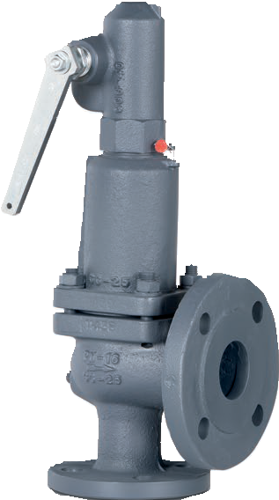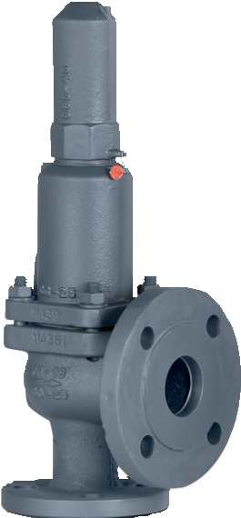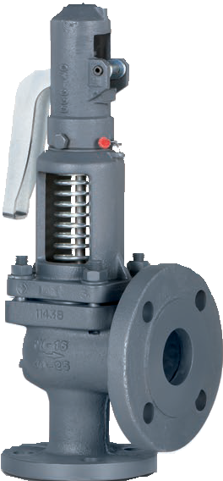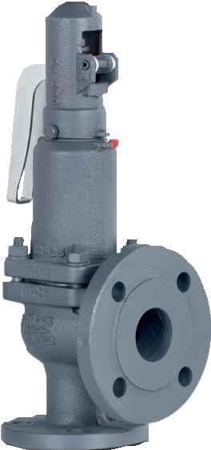The valve works as an automatic pressure releasing regulator activated by the static pressure existing at the entrance to the valve and is characterized by its ability to open instantly and totally.
Full lift safety valve with spring loading.(AIT)
Model 496
EP
AP
ES
CP

Design in accordance with “International Standard ISO 4126-1 Safety Valves”.
In accordance with the requirements of the pressure equipment directive 2014/68/EU.
EC valve verification certified by: TÜV Internacional Grupo TÜV Rheinland, S.L. EC 0035.
Type (Module D) EC examination report nº 33530455 certified by: TÜV Internacional Grupo TÜV Rheinland, S.L.
In compliance with the ATEX 2014/34/EU directive “Protective equipment and systems for use in potentially explosive atmospheres”.
Other authorisations: ISCIR, ITI, NASTHOL,EAC,...etc.

Specifications

90° angular flow.
- Activated by direct action helicoid spring.
- Simplicity of construction ensuring minimum maintenance.
- Materials carefully selected for their resistance to corrosion. With the exception of washers and couplings, the valves are free of non-ferric materials.
- Internal body designed to offer favourable flow profile.
- Sealing surfaces treated and balanced, making them extremely tightness, even exceeding EN 12266-1 requeriments.
- Great discharge capacity. For liquids typically used with openings similar to proportional safety valves.
- Equipped with draining screws for removing condensation.
- Auto-centering plug.
- Threaded shaft with lever positioner facilitating immediate manual action.
- Elevator, independent of the seal, designed facilitate sudden opening when the steam expands and, with any fluid, guarantees absolute opening and closing precision.
- All the valves are supplied sealed at the set pressure requested, simulating operational conditions, and are vigorously tested.
- All components are numbered, registered and checked. If requested in advance, material, casting, test and efficiency certificates will be enclosed with the valve, and the instruction manual, in accordance with P.E.D. 2014/68/EU.

IMPORTANT
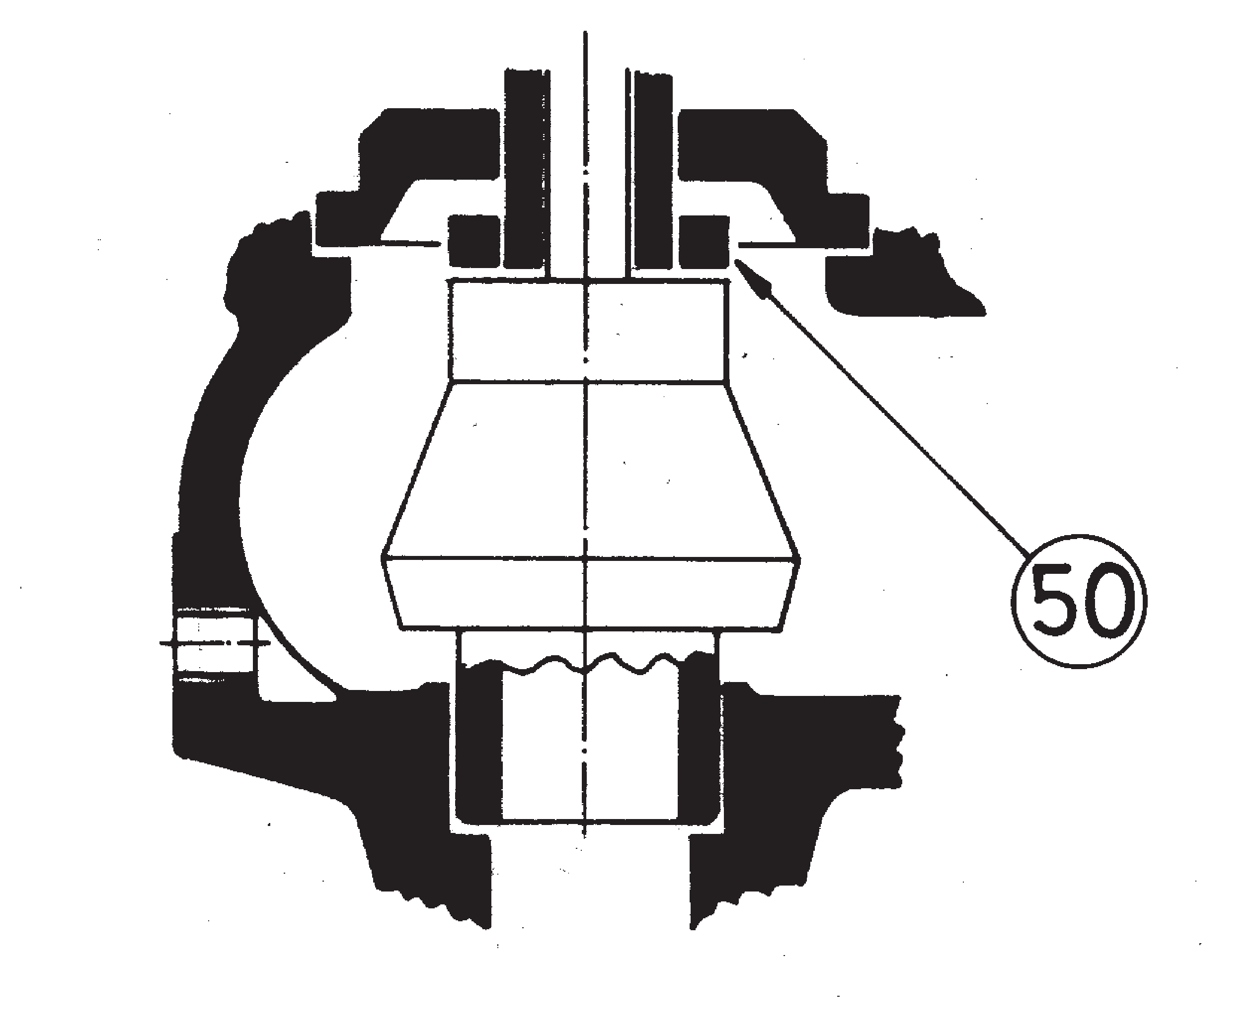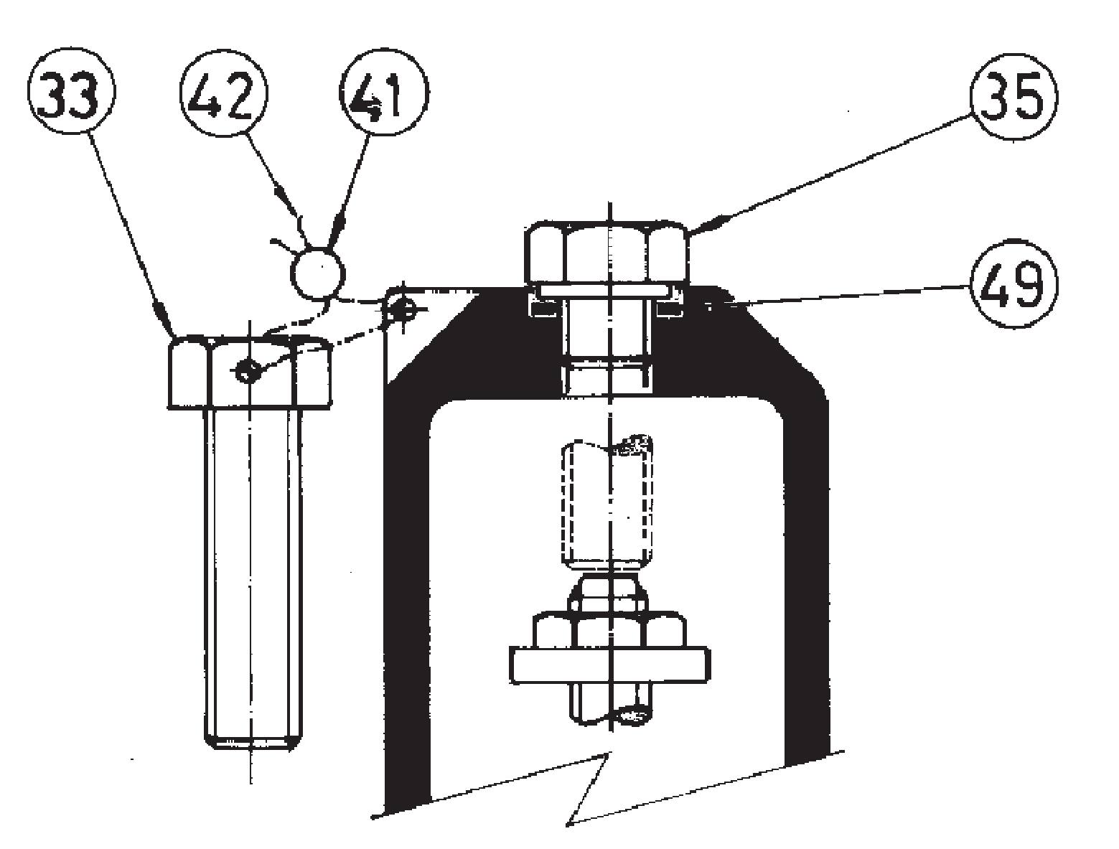Depending on demand:
2

1
1.- Blocking screw which facilitates hydrostatic testing of the container which to be protected.
2.- Rapid limiter to reduce the coefficient of discharge.
3.- Fluorelastomer (Vitón) seals, Silicone's rubber, PTFE (Teflón)... etc., achieving

leakage levels less than
0,3 x 10
Pa cm³
-3 seg.

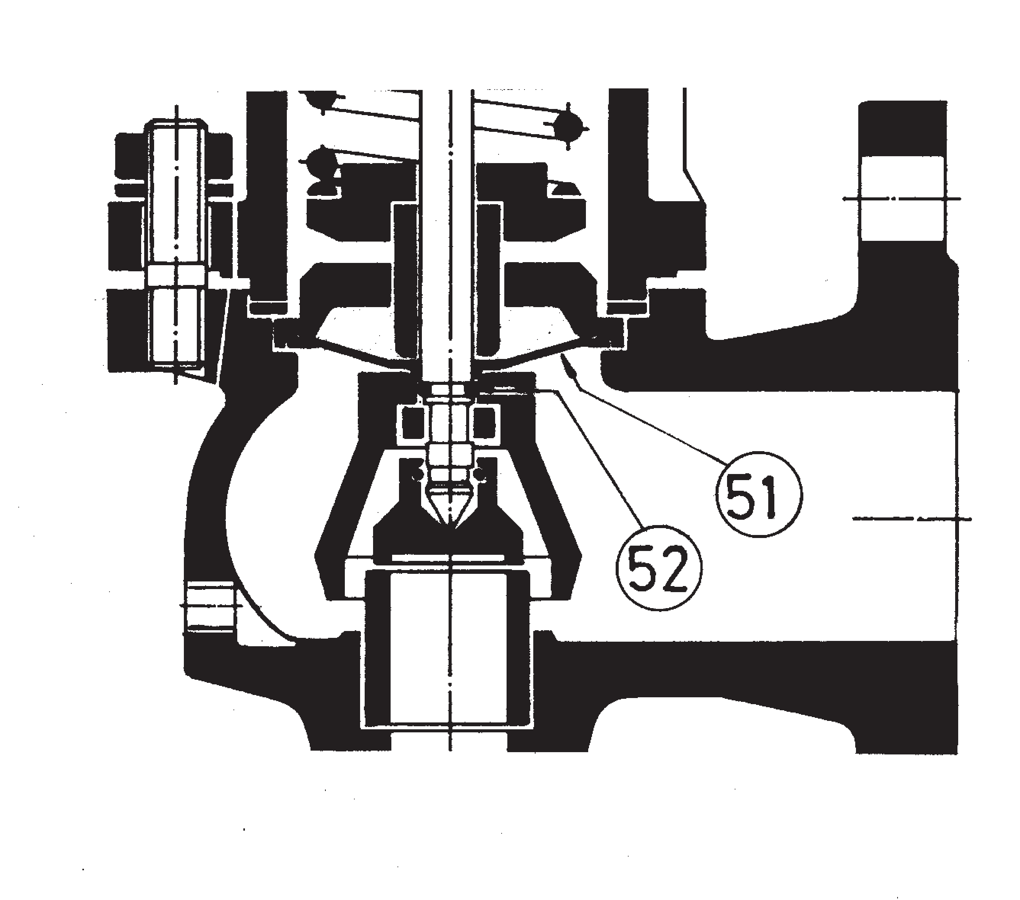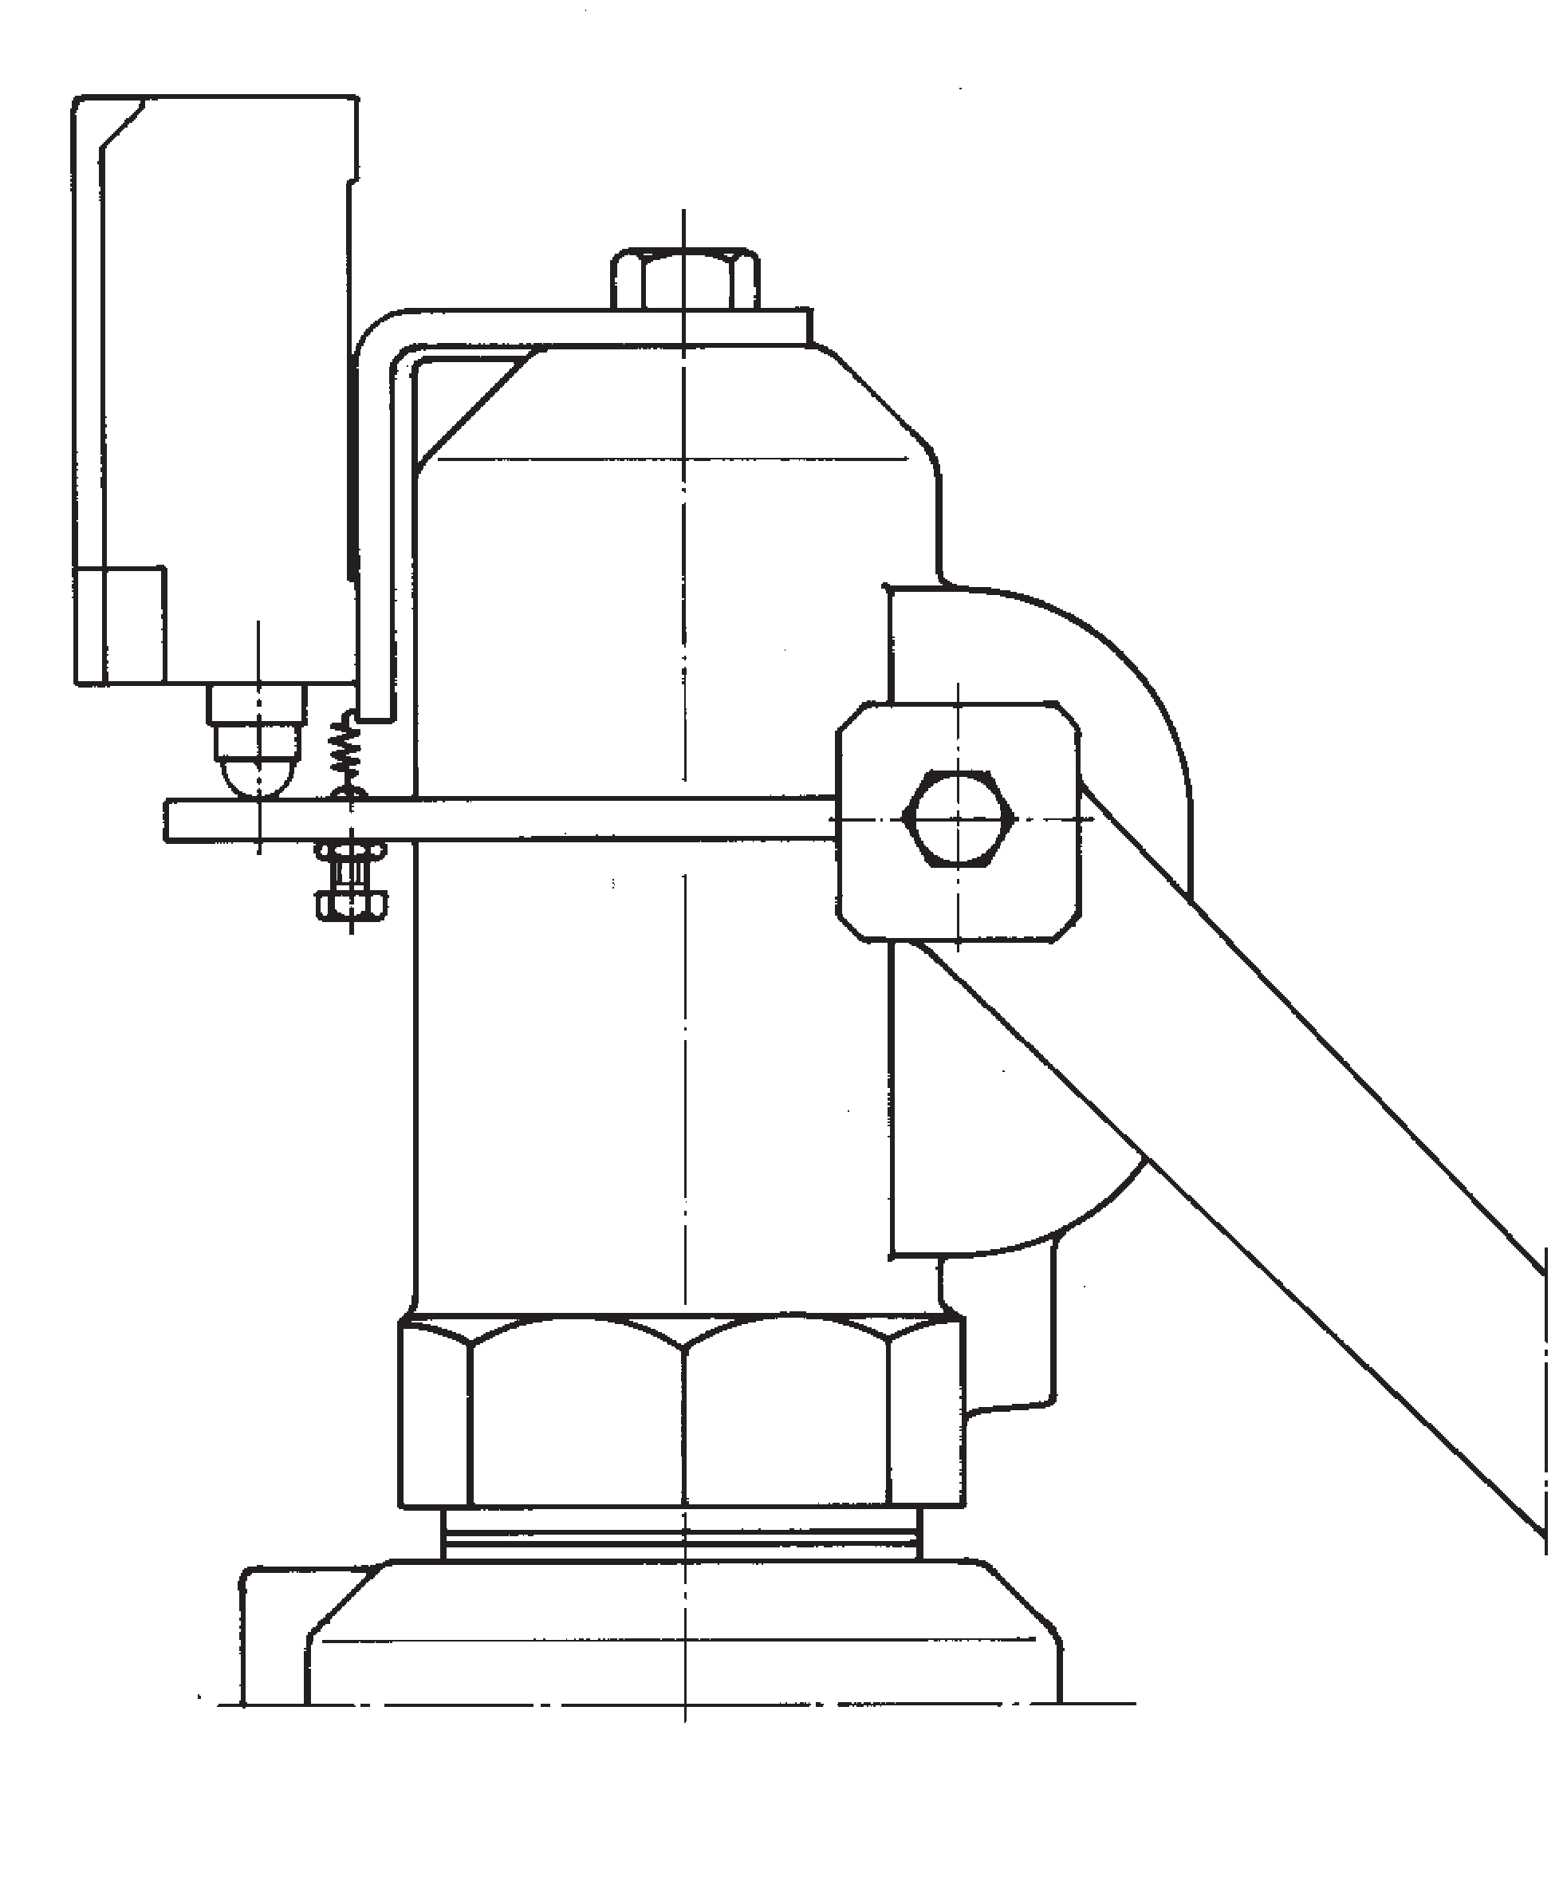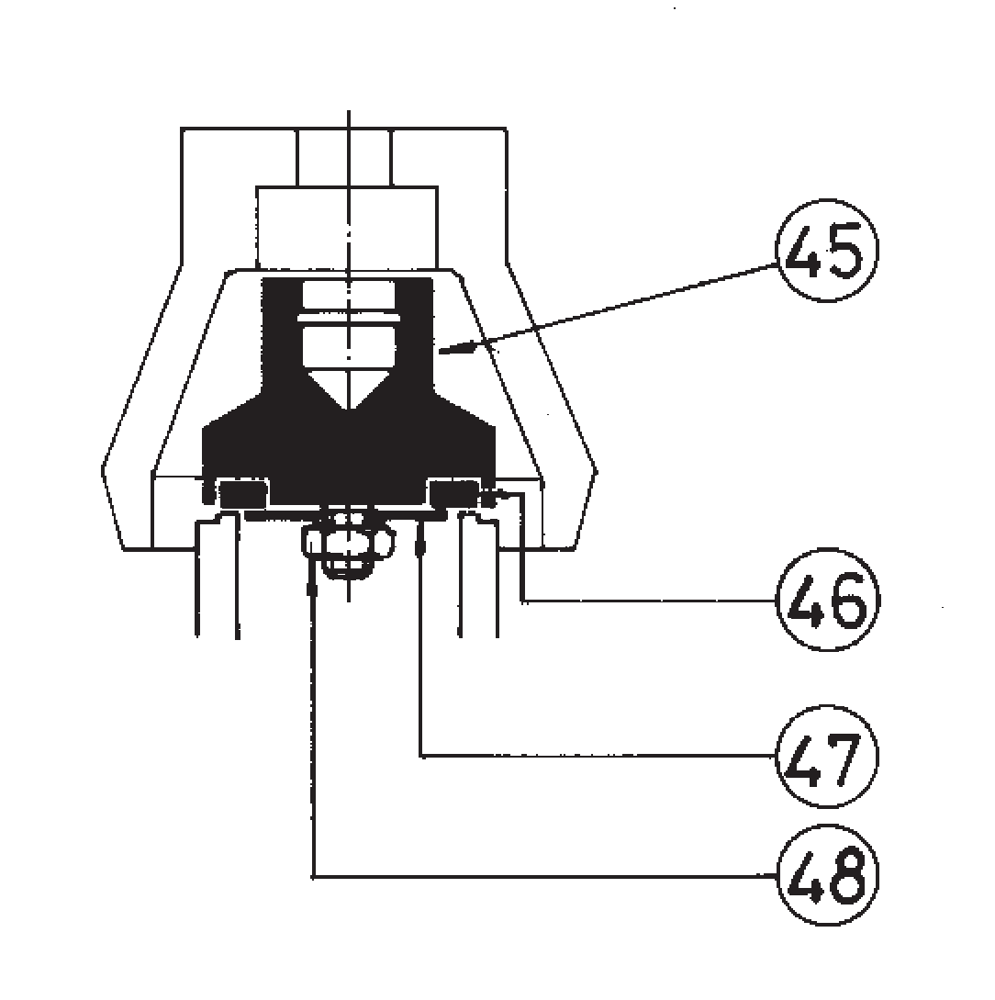The ranges of application allow certain flexibility although we recommend limiting them to:
4

5

3

RANGE OF APPLICATION FOR THE SEALS
FLUID |  | SET PRESSURE IN bar
 |  | 0,2 1,8 4,0 4,8 7,0 30 40,0
Saturated steam |  | S | V |  |  | T
Liquids and gases |  | S |  |  | V |  |  | T
SEALS |  | TEMPERATURE IN °C
 |  | ACCORDING TO MANUFACTURERS |  |  |  |  | RECOMMENDED BY VYC
 |  | MINIMUM |  | MAXIMUM |  |  | MINIMUM |  | MAXIMUM
Silicone's rubber | S | -60 |  | +200 |  |  | -50 |  | +115
Fluorelastomer (Vitón) | V | -40 |  | +250 |  |  | -30 |  | +150
PTFE (Teflón) | T | -265 |  | +260 |  |  | -80 |  | +230 (1)
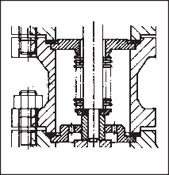(1) For temperatures exceeding 230°C apply metallic seal only.
6

4.- Flourelastomer (Vitón) membrane and O-ring isolating the rotating or sliding parts from the working fluid.
5.- Electrical contact indicating open/closed. 6.- Balance bellows to:
Protect the spring from atmospheric influences. Ensure outside of valve body is totally tightness. Level out external or self-generated back pressure.
7.- Possibility of manufacture in other types of material, for special operating con-
ditions (high temperatures, fluids, etc.).
8.- Totally free of oil and grease, to work with oxygen, avoiding possible fire risks (UV-Oxygen-VBG 62).
9.- Special springs for critical temperatures.
N°. PIECE | PIECE |  | MATERIAL
 |  |  | CAST IRON |  |  |  | NODULAR IRON |  |  |  |  | CAST STEEL |  |  |  |  |  |  | STAINLESS STEEL
1 | Body |  | Cast iron (EN-5.1301) |  |  |  | Nodular iron (EN-5.3106) |  |  |  |  | Cast steel (EN-1.0619+N) |  |  |  |  |  |  | Stainless steel (EN-1.4408)
2 | Closed bell |  | Cast iron (EN-5.1301) |  |  |  | Nodular iron (EN-5.3106) |  |  |  |  | Nodular iron (EN-5.3106) |  |  |  |  |  |  | Stainless steel (EN-1.4408)
3 | Open bell |  | Cast iron (EN-5.1301) |  |  |  | Nodular iron (EN-5.3106) |  |  |  |  | Cast steel (EN-1.0619+N) |  |  |  |  |  |  | Stainless steel (EN-1.4408)
4, 5, 6 | Hood |  | Nodular iron (EN-5.3106) |  |  |  | Nodular iron (EN-5.3106) |  |  |  |  | Nodular iron (EN-5.3106) |  |  |  |  |  |  | Stainless steel (EN-1.4408)
7 | Elevator |  | Nodular iron (EN-5.3106) (1) |  |  |  | Nodular iron (EN-5.3106) (1) |  |  |  |  | Nodular iron (EN-5.3106) (1) |  |  |  |  |  |  | Stainless steel (EN-1.4408)(7)
8 | Cam |  | Carbon steel (EN-1.0037 St-37.2) (6) |  |  |  | Carbon steel (EN-1.0037 St-37.2) (6) |  |  |  |  | Carbon steel (EN-1.0037 St-37.2) (6) |  |  |  |  |  |  | Stainless steel (EN-1.4301)
9, 10 | Lever |  | Carbon steel (EN-1.0037 St-37.2) |  |  |  | Carbon steel (EN-1.0037 St-37.2) |  |  |  |  | Carbon steel (EN-1.0037 St-37.2) |  |  |  |  |  |  | Carbon steel (EN-1.0037 St-37.2)
11 | Seating |  | Stainless steel (EN-1.4028) |  |  |  | Stainless steel (EN-1.4028) |  |  |  |  | Stainless steel (EN-1.4028) |  |  |  |  |  |  | Stainless steel (EN-1.4542)
12 | Plug |  | Stainless steel (EN-1.4028) |  |  |  | Stainless steel (EN-1.4028) |  |  |  |  | Stainless steel (EN-1.4028) |  |  |  |  |  |  | Stainless steel (EN-1.4542)
13 | Lead |  | Stainless steel (EN-1.4028) (4) |  |  |  | Stainless steel (EN-1.4028) (4) |  |  |  |  | Stainless steel (EN-1.4028) (4) |  |  |  |  |  |  | Stainless steel (EN-1.4401) (5)
14 | Spring press |  | Carbon steel (EN-1.1191) |  |  |  | Carbon steel (EN-1.1191) |  |  |  |  | Carbon steel (EN-1.1191) |  |  |  |  |  |  | Stainless steel (EN-1.4305)
15 | Separator |  | Stainless steel (EN-1.4028) |  |  |  | Stainless steel (EN-1.4028) |  |  |  |  | Stainless steel (EN-1.4028) |  |  |  |  |  |  | Stainless steel (EN-1.4401)
16 | Rod |  | Stainless steel (EN-1.4028) |  |  |  | Stainless steel (EN-1.4028) |  |  |  |  | Stainless steel (EN-1.4028) |  |  |  |  |  |  | Stainless steel (EN-1.4401)
17 | Lever shaft |  | Carbon steel (EN-1.1191) |  |  |  | Carbon steel (EN-1.1191) |  |  |  |  | Carbon steel (EN-1.1191) |  |  |  |  |  |  | Stainless steel (EN-1.4305)
18 | Gudgeon |  | Carbon steel (EN-1.1231) |  |  |  | Carbon steel (EN-1.1231) |  |  |  |  | Carbon steel (EN-1.1231) |  |  |  |  |  |  | Stainless steel (EN-1.4310)
19 | Ring |  | Stainless steel (EN-1.4028) |  |  |  | Stainless steel (EN-1.4028) |  |  |  |  | Stainless steel (EN-1.4028) |  |  |  |  |  |  | Stainless steel (EN-1.4401)
20, 21 | Safety ring |  | Stainless steel (EN-1.4310) |  |  |  | Stainless steel (EN-1.4310) |  |  |  |  | Stainless steel (EN-1.4310) |  |  |  |  |  |  | Stainless steel (EN-1.4310)
22 | Spring |  | Vanadium-chrome steel (EN-1.8159) (2) |  |  |  | Vanadium chrome steel (EN-1.8159) (2) |  |  |  |  | Vanadium chrome steel (EN-1.8159) (2) |  |  |  |  |  |  | Stainless steel (EN-1.4310) (3)
23 | Gland |  | Carbon steel (EN-1.1191) |  |  |  | Carbon steel (EN-1.1191) |  |  |  |  | Carbon steel (EN-1.1191) |  |  |  |  |  |  | Stainless steel (EN-1.4305)
24 | Hollow screw |  | Stainless steel (EN-1.4305) |  |  |  | Stainless steel (EN-1.4305) |  |  |  |  | Stainless steel (EN-1.4305) |  |  |  |  |  |  | Stainless steel (EN-1.4305)
25 | Hollow screw nut |  | Stainless steel (EN-1.4305) |  |  |  | Stainless steel (EN-1.4305) |  |  |  |  | Stainless steel (EN-1.4305) |  |  |  |  |  |  | Stainless steel (EN-1.4305)
26 | Buffer nut |  | Stainless steel (EN-1.4305) |  |  |  | Stainless steel (EN-1.4305) |  |  |  |  | Stainless steel (EN-1.4305) |  |  |  |  |  |  | Stainless steel (EN-1.4305)
27 | Rod check nut |  | Carbon steel (EN-1.1141) |  |  |  | Carbon steel (EN-1.1141) |  |  |  |  | Carbon steel (EN-1.1141) |  |  |  |  |  |  | Stainless steel (EN-1.4401)
28, 29, 48 | Nut |  | Carbon steel (EN-1.1141) |  |  |  | Carbon steel (EN-1.1141) |  |  |  |  | Carbon steel (EN-1.1141) |  |  |  |  |  |  | Stainless steel (EN-1.4401)
30, 31 | Washer |  | Carbon steel (EN-1.1141) |  |  |  | Carbon steel (EN-1.1141) |  |  |  |  | Carbon steel (EN-1.1141) |  |  |  |  |  |  | Stainless steel (EN-1.4401)
32 | Stud |  | Carbon steel (EN-1.1181) |  |  |  | Carbon steel (EN-1.1181) |  |  |  |  | Carbon steel (EN-1.1181) |  |  |  |  |  |  | Stainless steel (EN-1.4401)
33, 34, 35 | Screw |  | Carbon steel (EN-1.1191) |  |  |  | Carbon steel (EN-1.1191) |  |  |  |  | Carbon steel (EN-1.1191) |  |  |  |  |  |  | Stainless steel (EN-1.4401)
36 | Cap |  | Carbon steel (EN-1.1181) |  |  |  | Carbon steel (EN-1.1181) |  |  |  |  | Carbon steel (EN-1.1181) |  |  |  |  |  |  | Stainless steel (EN-1.4401)
38 | Coupling |  | Graphite |  |  |  | Graphite |  |  |  |  | Graphite |  |  |  |  |  |  | PTFE (Teflón)
39 | Coupling |  | PTFE (Teflón) |  |  |  | PTFE (Teflón) |  |  |  |  | PTFE (Teflón) |  |  |  |  |  |  | PTFE (Teflón)
40 | Seal |  | Graphite |  |  |  | Graphite |  |  |  |  | Graphite |  |  |  |  |  |  | PTFE (Teflón)
41 | Seal |  | Plastic |  |  |  | Plastic |  |  |  |  | Plastic |  |  |  |  |  |  | Plastic
42 | Sealing wire |  | Sealing wire |  |  |  | Sealing wire |  |  |  |  | Sealing wire |  |  |  |  |  |  | Sealing wire
43 | Characteristic plate |  | Stainless steel (EN-1.4301) |  |  |  | Stainless steel (EN-1.4301) |  |  |  |  | Stainless steel (EN-1.4301) |  |  |  |  |  |  | Stainless steel (EN-1.4301)
45 | Plug |  | Stainless steel (EN-1.4401) |  |  |  | Stainless steel (EN-1.4401) |  |  |  |  | Stainless steel (EN-1.4401) |  |  |  |  |  |  | Stainless steel (EN-1.4401)
46 | Sealing disk |  | PTFE (Teflón) |  |  |  | PTFE (Teflón) |  |  |  |  | PTFE (Teflón) |  |  |  |  |  |  | PTFE (Teflón)
 |  |  | Silicone's rubber |  |  |  | Silicone's rubber |  |  |  |  | Silicone's rubber |  |  |  |  |  |  | Silicone's rubber
 |  |  | Fluorelastomer (Vitón) |  |  |  | Fluorelastomer (Vitón) |  |  |  |  | Fluorelastomer (Vitón) |  |  |  |  |  |  | Fluorelastomer (Vitón)
47 | Washer |  | Stainless steel (EN-1.4401) |  |  |  | Stainless steel (EN-1.4401) |  |  |  |  | Stainless steel (EN-1.4401) |  |  |  |  |  |  | Stainless steel (EN-1.4401)
49 | Coupling |  | Copper |  |  |  | Copper |  |  |  |  | Copper |  |  |  |  |  |  | PTFE (Teflón)
50 | Limiter |  | Stainless steel (EN-1.4028) |  |  |  | Stainless steel (EN-1.4028) |  |  |  |  | Stainless steel (EN-1.4028) |  |  |  |  |  |  | Stainless steel (EN-1.4401)
51 | Membrane |  | Fluorelastomer (Vitón) |  |  |  | Fluorelastomer (Vitón) |  |  |  |  | Fluorelastomer (Vitón) |  |  |  |  |  |  | Fluorelastomer (Vitón)
52 | O-ring |  | Fluorelastomer (Vitón) |  |  |  | Fluorelastomer (Vitón) |  |  |  |  | Fluorelastomer (Vitón) |  |  |  |  |  |  | Fluorelastomer (Vitón)
DN1 x DN2 |  |  | 20 x 32 to 200 x 300
PN |  |  | 16 |  |  |  | 40 |  |  |  |  | 40 |  |  |  |  |  |  | 40
OPERATING CONDITIONS |  | PRESSURE IN bar | 16 | 13 | 13 | 13 | 40 | 35 | 32 | 28 | 24 | 40 | 35 | 32 | 28 | 24 | 21 | 20 | 40 | 34 | 32 | 29
 |  | MAX. TEMP. IN °C | 120 | 200 | 250 | 300 | 120 | 200 | 250 | 300 | 350 | 120 | 200 | 250 | 300 | 350 | 400 | 450 | 120 | 200 | 250 | 300
 |  | MIN. TEMP. IN °C | -10 |  |  |  | -10 |  |  |  |  | -10 |  |  |  |  |  |  | -60

- DN-20 x 32 in stainless steel (EN-1.4408).
- Spring steel (EN-10270-1-SH) for wire spring Ø < 10 mm. Maximum temperature EP, ES and CP 250°C / AP 400ºC.
- Vanadium chrome steel (EN-1.8159) for wire spring Ø > 10 mm.
- DN-200x300 in Stainless steel (DIN-1.4027).
- DN-200x300 in Stainless steel (EN-1.4408).
- DN-20x32 in Stainless steel (DIN-1.4301).
- DN-32x50 to DN-65x100 in Stainless steel (DIN-1.4401).

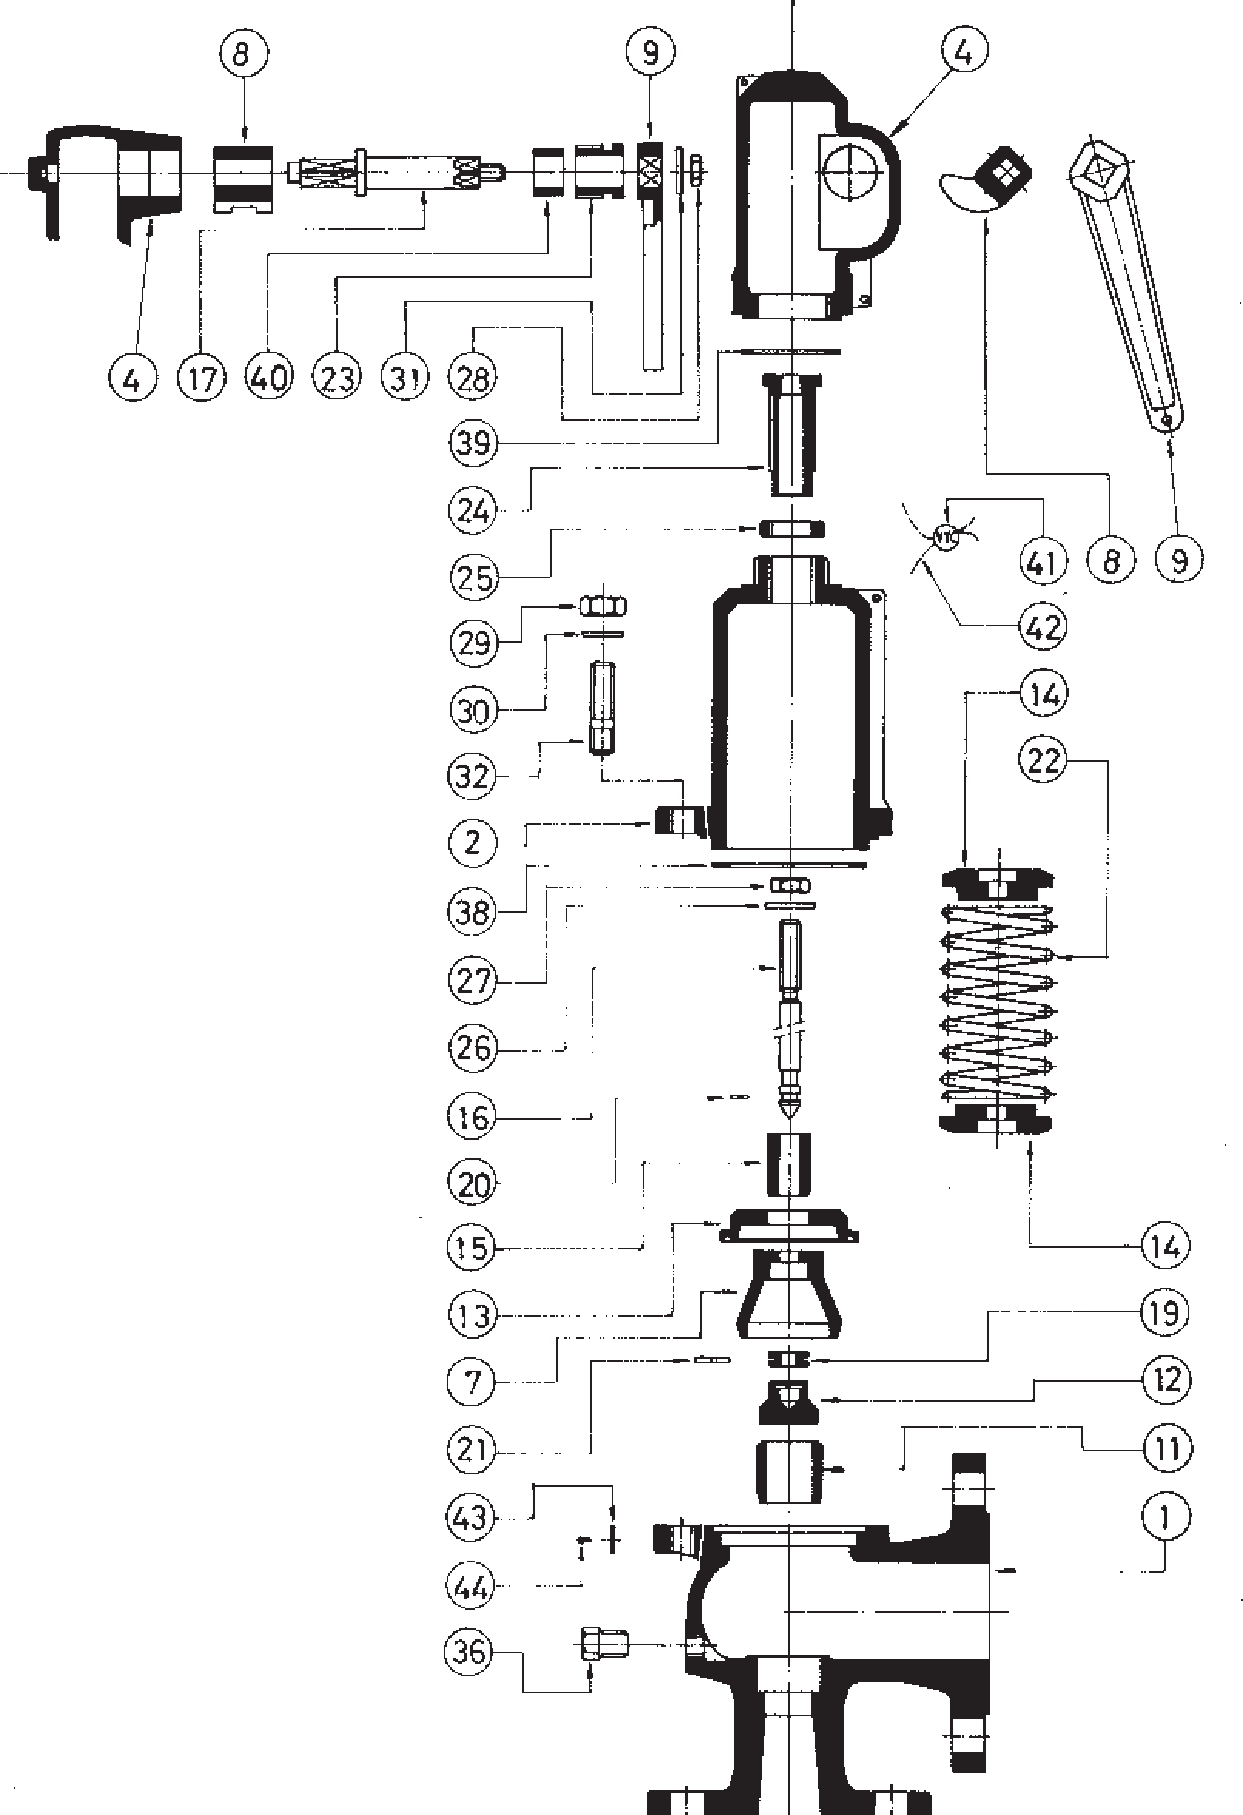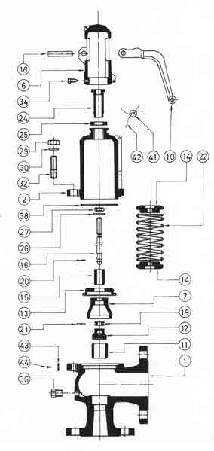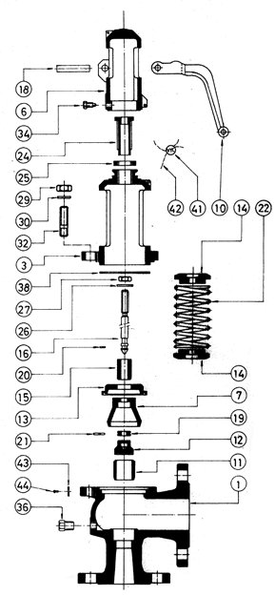Full lift safety valve with spring loading (AIT) model 496 - AP and CP.
AP
CP
EP

Disassembly and assembly.
    - Disassembly.
To replace the spring (22) or clean any of the internal components of the valve, proceed in the following manner: A - Withdraw the clip (18), using a punching tool, until the lever (10) comes free.
B - Loosen the screws (34) and take the cap (6) off.
C - Holding the spindle (16) steady, loosen the hollow screw nut (25) and the holow screw (24) until you note a realasing of the spring (22).
D - Mark on the spindle (16) the position of the spindle lock-nut (27) and the adjusting nut (26). Loosen them and remove them.
E - Unscrew the nuts (29) and remove them, together with the studs (32) and their washers (30). F - Lift the cover (3) or (2) and you will have access to all of the components.
    - Assembly.
A - Place the safety-ring (20) on the spindle (16) and press it against the gasket (12).
B - In the spindle channel (16) connect the ring (19) and fix it to the security-ring (21). IIntroduce the elevator (7) into the upper part of the spindle (16) and press this against the previously described pieces.
C - Enter the guide (13), the separator (15), the spring-press (14), the spring (22), the spring-press (14) through the upper part of the spindle (16) and press this against the previously descrobed pieces.
D - Replace the assembly (38) and the cover (3) or (2).
E - Place the washers (30) on the studs (32) and make up the nuts (29) diagonally, checking the correct alignment of the cover (3) or (2).
F - Adjust the firing pressure with the hollow screw (24) and fix the adjustment position with the hollow screw nut (25).
G - Turn the spindle lock-nut (27) and the adjusting nut (26) to the position mrked (see 1.1.D) and make up against each other.
H - Introduce the cap (6) and tighten the screws (34).
I - Place the lever (10) and fix it with the fastener (18).

Adjusting the firing pressure.
A - Proceed according to points 1.1.A, 1.1.B, 1.1.C. B - Proceed according to points 1.2.F, 1.2.H, 1.2.I.

Full lift safety valve with spring loading (AIT) model 496 - EP.

Disassembly and assembly .
  - Disassembly.
To replace the spring (22), or clean any of the internal components of the valve, proceed in the following manner: A - Move the lever (9) in direction C as far as the constructive catcher.
B - Unscrew the cap (4) and remove.
C - Holding the spindle (16) steady, loosen the hollow screw nut (25) and the hollow screw (24) until you note a realeasing of the spring (22).
D - Mark on the spindle (16) the position of the spindle lock-nut (27) and the adjusting nut (26). Loosen them and remove them.
E - Unscrew the nuts (29) and remove them, together with the studs (32) and their washers (30). F - Lift the cover (2) and you will have access to all of the components.
  - Assembly.
A - Place the safety-ring (20) on the spindle (16) and press it against the gasket (12).
B - In the spindle channel (16) connect the ring (19) and fix it to the security-ring (21). Introduce the elevator (7) into the upper part of the spindle (16) and press this against the previously described pieces.
C - Enter the guide (13), the separator (15), the spring-press (14), the spring (22), the spring-press (14) through the upper part of the spindle (16) in a correlative manner.
D - Replace the assembly (38) and the cover (2).
E - Place the washers (30) on the studs (32) and make up the nuts (29) diagonally, checking the correct alignment of the cover (2).
F - Adjust the firing pressure with the hollow screw (24) and fix the adjustment position with the hollow screw nut (25). G - Turn the spindle lock-nut (27) and the adjusting nut (26) to the position marked (see 1.1.D) and make up against each other.
H - Change the coupling (39) and lightly tighten the cap (4). Move the lever (9) towards position A as far as the constructive catcher. Definitively tighten the cap (4).

Adjustig the firing pressure.
A - Proceed according to points 1.1.A, 1.1.B, 1.1.C. B - Proceed according to points 1.2.F, 1.2.H.

Full lift safety valve with spring loading (AIT) model 496 - ES.

Disassembly and assembly.
  - Disassembly.
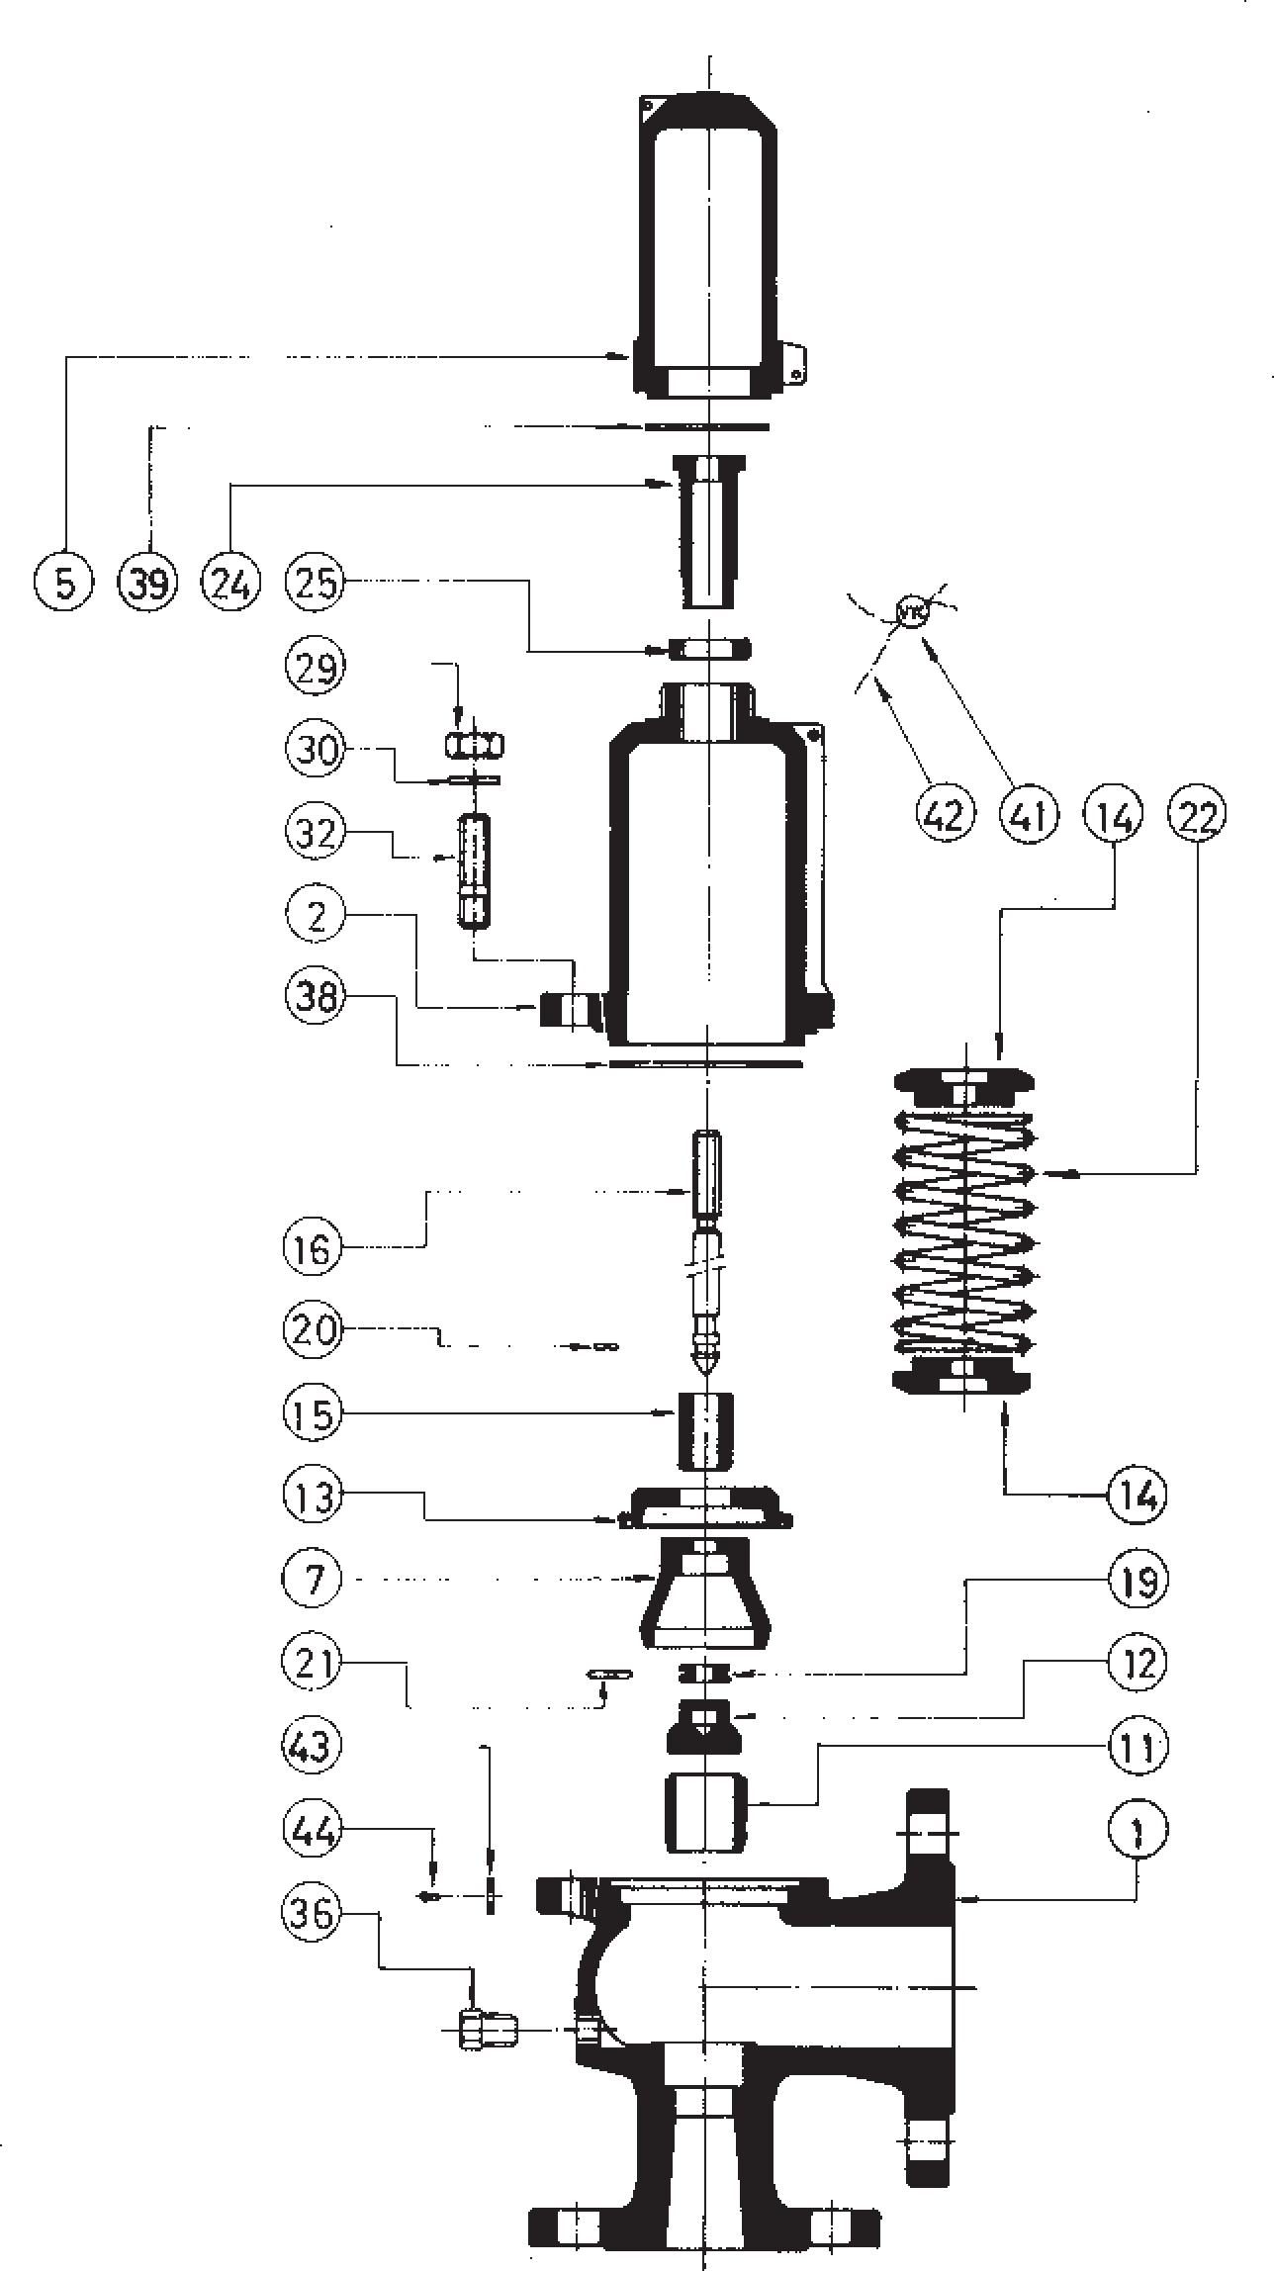To replace the spring (22), or clean any of the internal components of the valve, proceded in the following manner: A - Unscrew the cap (5) and remove.
ES
B - Holding the spindle (16) steady, loosen the hollow screw nut (25) and the hollow screw (24) until you note a realeasing of the spring (22).
C - Unscrew the nuts (29) and remove them, together with the studs (32) and their washers (30). F - Lift the cover (2) and you will have access to all of the components.
  - Assembly.
A - Place the safety-ring (20) on the spindle (16) and press it against the gasket (12). B - In the spindle channel (16) connect the ring (19) and fix it to the security-ring (21).
Introduce the elevator (7) into the upper part of the spindle (16) and press this against the previously described pieces.
C - Enter the guide (13), the separator (15), the spring-press (14), the spring (22), the spring-press (14) through the upper part of the spindle (16) in a correlative manner.
D - Replace the washers (38) and the cover (2).
E - Place the washers (30) on the studs (32) and make up the nuts (29) diagonally, checking the correct alignment of the cover (2).
F - Adjust the firing pressure with the hollow screw (24) and fix the adjustment position with the hollow screw nut (25).
G - Change the coupling (39) and tighten the cap (5).
- Adjusting the firing pressure.
A - Proceed according to points 1.1.A, 1.1.B. B - Proceed according to points 1.2.F, 1.2.G.

DN1 x DN2 |  |  | 20 x 32 |  |  |  | 25 x 40 |  |  |  | 32 x 50 |  |  |  | 40 x 65 |  |  |  | 50 x 80 |  |  |  | 65 x 100 |  |  |  | 80 x 125 |  |  |  | 100 x 150 |  |  |  | 125 x 200 |  |  |  | 150 x 250 |  |  |  | 200 x 300
do |  |  | 16 |  |  |  | 20 |  |  |  | 25 |  |  |  | 32 |  |  |  | 40 |  |  |  | 50 |  |  |  | 63 |  |  |  | 77 |  |  |  | 93 |  |  |  | 110 |  |  |  | 155
2  Ao = π • do  4 |  |  | 201 |  |  |  | 314 |  |  |  | 491 |  |  |  | 804 |  |  |  | 1257 |  |  |  | 1964 |  |  |  | 3117 |  |  |  | 4657 |  |  |  | 6793 |  |  |  | 9503 |  |  |  | 18870
H |  |  | 350 |  |  |  | 395 |  |  |  | 415 |  |  |  | 500 |  |  |  | 555 |  |  |  | 660 |  |  |  | 710 |  |  |  | 810 |  |  |  | 858 |  |  |  | 1029 |  |  |  | 1252
h1 |  |  | 112 |  |  |  | 129 |  |  |  | 129 |  |  |  | 148 |  |  |  | 148 |  |  |  | 191 |  |  |  | 191 |  |  |  | 191 |  |  |  | 191 |  |  |  | 247 |  |  |  | 331
L1 |  |  | 85 |  |  |  | 95 |  |  |  | 100 |  |  |  | 115 |  |  |  | 125 |  |  |  | 140 |  |  |  | 155 |  |  |  | 175 |  |  |  | 215 |  |  |  | 225 |  |  |  | 265
L2 |  |  | 95 |  |  |  | 105 |  |  |  | 110 |  |  |  | 130 |  |  |  | 145 |  |  |  | 150 |  |  |  | 170 |  |  |  | 180 |  |  |  | 220 |  |  |  | 245 |  |  |  | 290
R |  |  | 1/4" |  |  |  | 1/4" |  |  |  | 1/4" |  |  |  | 1/4" |  |  |  | 1/4" |  |  |  | 3/8" |  |  |  | 3/8" |  |  |  | 3/8" |  |  |  | 1/2” |  |  |  | 1/2” |  |  |  | 1/2”
 |  |  | Whitworth gas-tight cylindrical female thread ISO 228/1 1978 (DIN-259)
INTAKE FLANGE | PN-10/16 EN-1092-2 (2) | D1 | 105 |  |  |  | 115 |  |  |  | 140 |  |  |  | 150 |  |  |  | 165 |  |  |  | 185 |  |  |  | 200 |  |  |  | 220 |  |  |  | 250 |  |  |  | 285 |  |  |  | 340
 |  | K1 | 75 |  |  |  | 85 |  |  |  | 100 |  |  |  | 110 |  |  |  | 125 |  |  |  | 145 |  |  |  | 160 |  |  |  | 180 |  |  |  | 210 |  |  |  | 240 |  |  |  | 295
 |  | I1 | 14 |  |  |  | 14 |  |  |  | 19 |  |  |  | 19 |  |  |  | 19 |  |  |  | 19 |  |  |  | 19 |  |  |  | 19 |  |  |  | 19 |  |  |  | 23 |  |  |  | 23
 |  | b1 | 16 |  |  |  | 16 |  |  |  | 18 |  |  |  | 18 |  |  |  | 20 |  |  |  | 20 |  |  |  | 22 |  |  |  | 24 |  |  |  | 26 |  |  |  | 26 |  |  |  | 26
 |  | DRILLS N.° | 4 |  |  |  | 4 |  |  |  | 4 |  |  |  | 4 |  |  |  | 4 |  |  |  | 4 |  |  |  | 8 |  |  |  | 8 |  |  |  | 8 |  |  |  | 8 |  |  |  | 8
 | PN-25/40 EN-1092-2 (3)  EN-1092-1 | D1 | 105 |  |  |  | 115 |  |  |  | 140 |  |  |  | 150 |  |  |  | 165 |  |  |  | 185 |  |  |  | 200 |  |  |  | 235 |  |  |  | 270 |  |  |  | 300 |  |  |  | 360
 |  | K1 | 75 |  |  |  | 85 |  |  |  | 100 |  |  |  | 110 |  |  |  | 125 |  |  |  | 145 |  |  |  | 160 |  |  |  | 190 |  |  |  | 220 |  |  |  | 250 |  |  |  | 310
 |  | I1 | 14 |  |  |  | 14 |  |  |  | 19(18)* |  |  |  | 19(18)* |  |  |  | 19(18)* |  |  |  | 19(18)* |  |  |  | 19(18)* |  |  |  | 23(22)* |  |  |  | 28(26)* |  |  |  | 28(26)* |  |  |  | 28(26)*
 |  | b1 | 18(16)• |  |  |  | 18(16)• |  |  |  | 18 |  |  |  | 18(20)• |  |  |  | 20 |  |  |  | 22 |  |  |  | 24 |  |  |  | 24 |  |  |  | 26 |  |  |  | 28 |  |  |  | 30
 |  | DRILLS N.° | 4 |  |  |  | 4 |  |  |  | 4 |  |  |  | 4 |  |  |  | 4 |  |  |  | 8 |  |  |  | 8 |  |  |  | 8 |  |  |  | 8 |  |  |  | 8 |  |  |  | 12
ESCAPE FLANGE | PN-10/6 EN-1092-2 (1)  EN-1092-1 | D2 | 140 |  |  |  | 150 |  |  |  | 165 |  |  |  | 185 |  |  |  | 200 |  |  |  | 220 |  |  |  | 250 |  |  |  | 285 |  |  |  | 340 |  |  |  | 395 |  |  |  | 445
 |  | K2 | 100 |  |  |  | 110 |  |  |  | 125 |  |  |  | 145 |  |  |  | 160 |  |  |  | 180 |  |  |  | 210 |  |  |  | 240 |  |  |  | 295 |  |  |  | 350 |  |  |  | 400
 |  | I2 | 19(18)* |  |  |  | 19(18)* |  |  |  | 19(18)* |  |  |  | 19(18)* |  |  |  | 19(18)* |  |  |  | 19(18)* |  |  |  | 19(18)* |  |  |  | 23(22)* |  |  |  | 23(22)* |  |  |  | 23(22)* |  |  |  | 23(22)*
 |  | b2 | 18 |  |  |  | 18 |  |  |  | 20 |  |  |  | 20(18)* |  |  |  | 22(20)•* |  |  |  | 24(22)•(20)* |  |  |  | 26(22)•* |  |  |  | 26(24)•(22)* |  |  |  | 26(24)•* |  |  |  | 28(26)•* |  |  |  | 28(26)•*
 |  | DRILLS N.° | 4 |  |  |  | 4 |  |  |  | 4 |  |  |  | 4 |  |  |  | 8 |  |  |  | 8 |  |  |  | 8 |  |  |  | 8 |  |  |  | 8 |  |  |  | 12 |  |  |  | 12
MODEL |  |  | EP | AP | ES | CP | EP | AP | ES | CP | EP | AP | ES | CP | EP | AP | ES | CP | EP | AP | ES | CP | EP | AP | ES | CP | EP | AP | ES | CP | EP | AP | ES | CP | EP | AP | ES | CP | EP | AP | ES | CP | EP | AP | ES | CP
WEIGHT IN kgs. | CAST IRON |  | 8,00 | 7,40 | 7,60 | 7,80 | 9,60 | 8,88 | 9,12 | 9,38 | 13,87 | 12,82 | 13,17 | 13,43 | 20,27 | 18,74 | 19,25 | 19,68 | 26,68 | 24,67 | 25,34 | 25,77 | 39,48 | 36,52 | 37,50 | 38,10 | 55,48 | 51,32 | 52,70 | 53,30 | 82,15 | 75,98 | 78,04 | 78,64 | 94,50 | 88,64 | 92,80 | 93,33 | 138,10 | 130,80 | 135,10 | 136,37 | 228,10 | 214,60 | 221,72 | 224,30
 | NODULAR IRON |  | 8,73 | 8,07 | 8,29 | 8,49 | 10,47 | 9,68 | 9,94 | 10,20 | 15,13 | 13,99 | 14,37 | 14,63 | 22,11 | 20,45 | 21,00 | 21,43 | 29,11 | 26,92 | 27,65 | 28,08 | 43,08 | 39,84 | 40,92 | 41,52 | 60,54 | 55,99 | 57,51 | 58,11 | 89,64 | 82,91 | 85,15 | 85,75 | 97,00 | 91,16 | 95,39 | 95,84 | 173,48 | 136,25 | 140,43 | 141,80 | 234,63 | 221,14 | 228,25 | 230,83
 | CAST STEEL STAINLESS STEEL |  | 8,50 | 7,86 | 8,07 | 8,27 | 10,60 | 9,80 | 10,07 | 10,33 | 14,87 | 13,75 | 14,12 | 14,38 | 21,27 | 19,67 | 20,20 | 20,63 | 28,68 | 26,52 | 27,24 | 27,67 | 41,48 | 38,36 | 39,40 | 40,00 | 58,48 | 54,09 | 55,55 | 56,15 | 87,15 | 80,61 | 82,79 | 83,39 | 104,38 | 97,86 | 102,65 | 103,10 | 152,10 | 144,48 | 149,30 | 180,65 | 250,88 | 235,94 | 243,61 | 246,75
CODE | CAST IRON 2002-496. |  | 5346 | 53461 | 53462 | 53463 | 5106 | 51061 | 51062 | 51063 | 5146 | 51461 | 51462 | 51463 | 5126 | 51261 | 51262 | 51263 | 5206 | 52061 | 52062 | 52063 | 5226 | 52261 | 52262 | 52263 | 5306 | 53061 | 53062 | 53063 | 5406 | 54061 | 54062 | 54063 | 5506 | 55061 | 55062 | 55063 | 5606 | 56061 | 56062 | 56063 | 5806 | 58061 | 58062 | 58063
 | NODULAR IRON 2002-496. |  | 8346 | 83461 | 83462 | 83463 | 8106 | 81061 | 81062 | 81063 | 8146 | 81461 | 81462 | 81463 | 8126 | 81261 | 81262 | 81263 | 8206 | 82061 | 82062 | 82063 | 8226 | 82261 | 82262 | 82263 | 8306 | 83061 | 83062 | 83063 | 8406 | 84061 | 84062 | 84063 | 8506 | 85061 | 85062 | 85063 | 8606 | 86061 | 86062 | 86063 | 8806 | 88061 | 88062 | 88063
 | CAST STEEL 2002-496. |  | 8344 | 83441 | 83442 | 83443 | 8104 | 81041 | 81042 | 81043 | 8144 | 81441 | 81442 | 81443 | 8124 | 81241 | 81242 | 81243 | 8204 | 82041 | 82042 | 82043 | 8224 | 82241 | 82242 | 82243 | 8304 | 83041 | 83042 | 83043 | 8404 | 84041 | 84042 | 84043 | 8504 | 85041 | 85042 | 85043 | 8604 | 86041 | 86042 | 86043 | 8804 | 88041 | 88042 | 88043
 | STAINLESS STEEL 2002-496. |  | 8342 | 83421 | 83422 | 83423 | 8102 | 81021 | 81022 | 81023 | 8142 | 81421 | 81422 | 81423 | 8122 | 81221 | 81222 | 81223 | 8202 | 82021 | 82022 | 82023 | 8222 | 82221 | 82222 | 82223 | 8302 | 83021 | 83022 | 83023 | 8402 | 84021 | 84022 | 84023 | 8402 | 84021 | 84022 | 84023 | 8602 | 86021 | 86022 | 86023 | 8802 | 88021 | 88022 | 88023

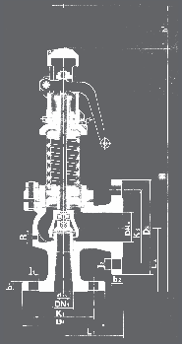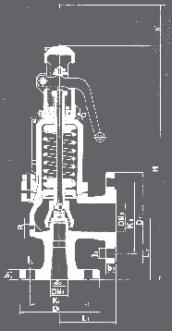

CP

EP AP ES

OPEN AND CLOSED PRESSURES IN % OF SET PRESSURE
FLUIDO | PRESSURE IN bar | OPENING PRESSURE | CLOSING PRESSURE
SATURATED STEAM  GASES | < 3 | + 5 % | - 0,3 bar
 | >_ 3 | + 5 % | - 10 %
LIQUIDS | < 3 | + 10 % | - 0,6 bar
 | >_ 3 | + 10 % | - 20 %

(1)
(1) From DN-125x200 PN-10. (2) DN-200x300 PN-10.
(3) DN-200x300 PN-25.
* Cast steel (EN-1.0619) and Stainless steel (EN-1.4408).
- Nodular iron (EN-5.3106).
RECOMMENDED RANGES OF APPLICATION
MODEL |  |  | EP | AP₍₁₎ | ES | CP₍₁₎
FLUID |  | SATURATED STEAM | * | * |  | *
 |  | GASES | * |  | *
 |  | LIQUIDS | * |  | *
PERMISSIBLE BACK PRESSURE IN %  OF SET PRESSURE | INTERNAL OR GENERATED | SATURATED STEAM GASES | 15
 |  | LIQUIDS | —
 | EXTERNAL VARIABLE (1) | SATURATED STEAM GASES | 5
 |  | LIQUIDS | —
 | EXTERNAL CONSTANT (1)(2)(3) | SATURATED STEAM GASES | 50
 |  | LIQUIDS | 90
% OVERPRESSURE |  | SATURATED STEAM GASES | 10
 |  | LIQUIDS | 25

(2)

(3)
If external backpressure exists, the AP and CP model cannot be used.
With external constant backpressure, the spring is adjusted deducting the backpressure from the set pressure.
If the set pressure < 3 bar we must consider the total atmospheric pressure (1 bar) as external constant backpressure being freely released.
If pa > 0,25p, we must limit plug speed with the consequent reduction of the ad coefficient of discharge.
With the new reduced coefficient we determine the d0, in order to remove the necessary volume..
pa = Backpressure permitted [bar] absolute. p = Set pressure [bar] absolute.
ad = Coefficient of discharge.

SET PRESSURES AND REGULATING RANGES
DN1 x DN2 |  |  | 20 x 32 | 25 x 40 | 32 x 50 | 40 x 65 | 50 x 80 | 65 x 100 | 80 x 125 | 100 x 150 | 125 x 200 | 150x250 | 200x300
SET PRESSURES IN bar | MAXIMUM  (LIQUIDS AND GASES) | PN-16 | 16 | 16 | 16 | 16 | 16 | 16 | 16 | 16 | 12,5 | 10 | 8
 |  | PN-40 | 40 | 40 | 40 | 32 | 32 | 32 | 25 | 20 | 12,5 | 10 | 8
 | MAXIMUM  (SATURATED STEAM) | PN-16 | 13 | 13 | 13 | 13 | 13 | 13 | 13 | 13 | 12,5 | 10 | 8
 |  | PN-40 | 32 | 32 | 30 | 24 | 22 | 24 | 20 | 18 | 12,5 | 10 | 8
 | MINIMUM | STEAM AND GASES | 0,5 | 0,5 | 0,5 | 0,5 | 0,5 | 0,5 | 0,5 | 0,5 | 0,5 | 0,5 | 0,5
 |  | LIQUIDS | 0,2 | 0,2 | 0,2 | 0,2 | 0,2 | 0,2 | 0,2 | 0,2 | 0,2 | 0,2 | 0,2
SPRING REGULATING RANGE IN bar | 0,20 to 0,68 | CODE | 56210  56390 | 56226  56406 | 56242  56422 | 56258  56438 | 56453  56453 | 56288  56468 | 56303  56483 | 56317  56497 | 56500 | 56511 | 56521
 | 0,66 to 1,00 | CODE | 56211  56391 | 56227  56407 | 56243  56423 | 56259  56439 | 56454  56454 | 56289  56469 | 56304  56484 | 56318 | 56501 | 56512 | 56522
 | 0,95 to 1,40 | CODE | 56212  56392 | 56228  56408 | 56244  56424 | 56260  56440 | 56455  56455 | 56290  56470 | 56305  56485 | 56319 | 56502 | 56513 | 56523
 | 1,30 to 1,90 | CODE | 56213  56393 | 56229  56409 | 56245  56425 | 56261  56441 | 56456  56456 | 56291  56471 | 56306  56486 | 56320 | 56503 | 56514 | 56524
 | 1,80 to 2,60 | CODE | 56214  56394 | 56230  56410 | 56246  56426 | 56262  56442 | 56457  56457 | 56292  56472 | 56307 | 56321 | 56504 | 56515 | 56525
 | 2,50 to 3,60 | CODE | 56215  56395 | 56231  56411 | 56247  56427 | 56263  56443 | 56458  56458 | 56293  56473 | 56308 | 56322 | 56505 | 56516 | 56526
 | 3,50 to 5,00 | CODE | 56216  56396 | 56232  56412 | 56248  56428 | 56264  56444 | 56459  56459 | 56294 | 56309 | 56323 | 56506 | 56517 | 56527
 | 4,80 to 6,30 | CODE | 56217  56397 | 56233  56413 | 56249  56429 | 56265  56445 | 56460  56460 | 56295 | 56310 | 56324 | 56507 | 56518 | 56528
 | 6,00 to 8,00 | CODE | 56218  56398 | 56234  56414 | 56250  56430 | 56266  56446 | 56461  56461 | 56296 | 56311 | 56325 | 56508 | 56519 | 56529
 | 7,50 to 10,00 | CODE | 56219  56399 | 56235  56415 | 56251  56431 | 56267  56447 | 56462  56462 | 56297 | 56312 | 56326 | 56509 | 56520
 | 9,50 to 12,50 | CODE | 56220  56400 | 56236  56416 | 56252  56432 | 56268  56448 | 56283 | 56298 | 56313 | 56327 | 56510
 | 12,00 to 16,00 | CODE | 56221  56401 | 56237  56417 | 56253  56433 | 56269  56449 | 56284 | 56299 | 56314 | 56328
 | 15,00 to 20,00 | CODE | 56222  56402 | 56238  56418 | 56254  56434 | 56270 | 56285 | 56300 | 56315 | 56329
 | 18,00 to 25,00 | CODE | 56223  56403 | 56239  56419 | 56255  56435 | 56271 | 56286 | 56301 | 56316
 | 23,00 to 32,00 | CODE | 56224  56404 | 56240  56420 | 56256  56436 | 56272 | 56287 | 56302
 | 30,00 to 40,00 | CODE | 56225  56405 | 56241  56421 | 56257  56437
Spring steel (EN-10270-1-SH). Maximum temperature for EP, ES and CP models 250°C / AP 400ºC. Vanadium-chrome steel (EN-1.8159).
Stainless steel (EN-1.4310).

COEFFICIENT OF DISCHARGE
DN1 x DN2 |  | 20 x 32 | 25 x 40 | 32 x 50 | 40 x 65 | 50 x 80 | 65 x 100 | 80 x 125 | 100 x 150 | 125x200 | 150x250 | 200x300
do |  | 16 | 20 | 25 | 32 | 40 | 50 | 63 | 77 | 93 | 110 | 155
h |  | 7,00 | 9,00 | 12,00 | 12,00 | 18,00 | 18,00 | 20,00 | 29,00 | 34,40 | 36,80 | 56,15
h1 |  | 2,60 | 3,20 | 04,00 | 05,20 | 06,50 | 08,00 | 10,00 | 12,50 | 16,74 | 19,80 | 27,90
h/do |  | 0,44 | 0,45 | 00,48 | 00,38 | 00,45 | 00,36 | 00,32 | 00,38 | 0,37 | 0,33 | 0,36
h1/do ₍₁₎ |  | 0,16 | 0,16 | 00,16 | 00,16 | 00,16 | 00,16 | 00,16 | 00,16 | 0,18 | 0,18 | 0,18
COEFFICIENT OF DISCHARGE  kd | SATURATED STEAM GASES | 0,78 |  |  |  |  |  |  |  | 0,78 | 0,78 | 0,74
 | LIQUIDES | 0,60 |  |  |  |  |  |  |  | 0,52
 | LIQUIDS WITH RAPID LIMITER (1) | 0,36

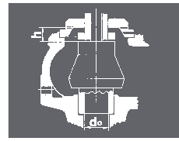
1,28
1,26
1,24
1,22
1,20
1,18
1,16
1,14
1,12
1,10
1,08
1,06
1,04
1,02
1,00

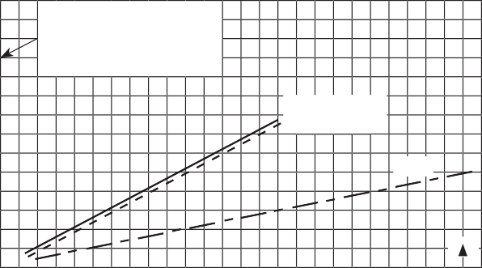5 10 15
Overpressure factors
Multiply the discharge capacity obtained from the tables, by the correction factor, in order to obtain the discharge capacity at required overpressure.
Air
Saturated steam
Water
% p
Overpressure in %

20 25

Liquids Saturated steam
Gases
Saturated steam Gases

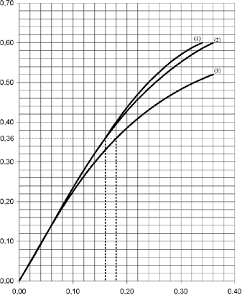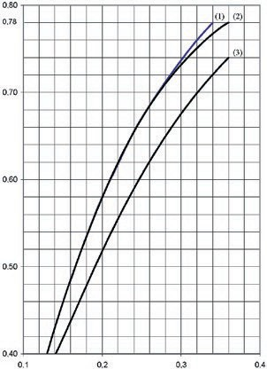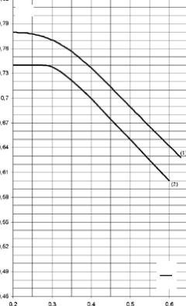
kd
h
d0
0,80
0,78 kd
0,70
0,60
0,50
0,40
0,1
0,2
0,3
0,4
h
d0
pa
p
kd

(1) d0 16-63
(2) d0 77
(3) d0 93-155
(1) d0 16-77
(2) d0 93-110
(3) d0 155
(1) d0 16-110
(2) d0 155

DN1 x DN2 | 20 x 32 |  |  | 25 x 40
do | 16 |  |  | 20
2  Ao= π • do  4 | 201 |  |  | 314
p [bar]

SET PRESSURE
IN bar
 | I | II | III | I | II | III
0,5 | 101 | 121 | 4310 | 157 | 200 | 6734
1,0 | 151 | 182 | 6096 | 236 | 285 | 9523
1,5 | 200 | 244 | 7466 | 312 | 380 | 11664
2,0 | 246 | 300 | 8621 | 385 | 469 | 13468
2,5 | 290 | 356 | 9639 | 453 | 569 | 15058
3,0 | 334 | 414 | 10559 | 522 | 648 | 16495
3,5 | 375 | 466 | 11405 | 585 | 730 | 17817
4,0 | 415 | 518 | 12192 | 648 | 811 | 19047
4,5 | 455 | 570 | 12932 | 711 | 892 | 20202
5,0 | 496 | 622 | 13632 | 774 | 973 | 21295
6,0 | 576 | 725 | 14933 | 899 | 1135 | 23328
7,0 | 656 | 829 | 16129 | 1024 | 1298 | 25197
8,0 | 736 | 933 | 17243 | 1149 | 1460 | 26936
9,0 | 815 | 1036 | 18288 | 1273 | 1622 | 28570
10,0 | 894 | 1140 | 19278 | 1397 | 1784 | 30116
12,0 | 1053 | 1347 | 21118 | 1645 | 2109 | 32990
14,0 | 1211 | 1555 | 22810 | 1891 | 2433 | 35634
16,0 | 1369 | 1762 | 24385 | 2139 | 2758 | 38094
18,0 | 1526 | 1969 | 25864 | 2384 | 3082 | 40405
20,0 | 1684 | 2177 | 27263 | 2631 | 3407 | 42590
22,0 | 1841 | 2384 | 28594 | 2876 | 3731 | 44669
24,0 | 2000 | 2592 | 29865 | 3124 | 4056 | 46656
26,0 | 2157 | 2799 | 31085 | 3370 | 4380 | 48561
28,0 | 2316 | 3006 | 32258 | 3618 | 4705 | 50394
30,0 | 2472 | 3214 | 33390 | 3861 | 5029 | 52163
32,0 | 2630 | 3421 | 34486 | 4109 | 5353 | 53873
34,0 |  | 3628 | 35547 |  | 5678 | 55531
36,0 |  | 3836 | 36578 |  | 6002 | 57141
38,0 |  | 4043 | 37580 |  | 6327 | 58707
40,0 |  | 4250 | 38556 |  | 6651 | 60232

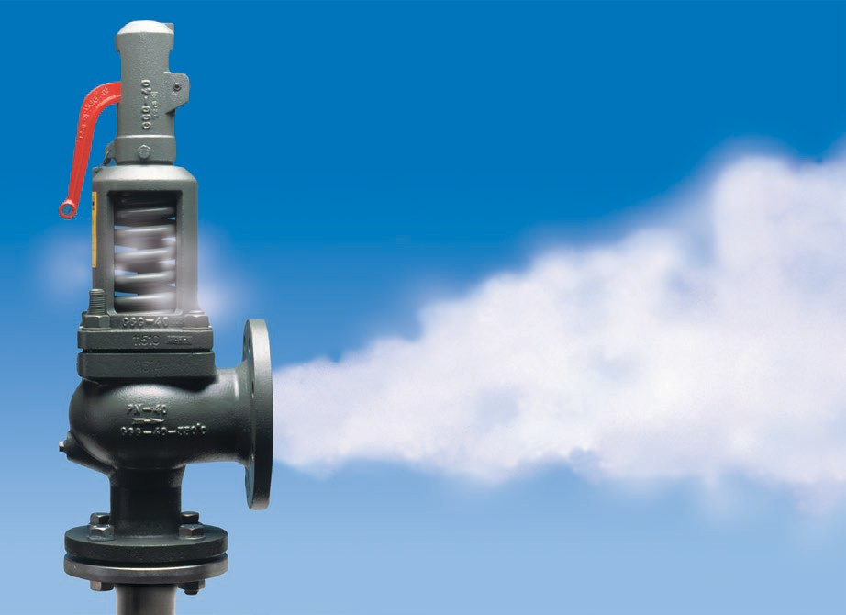

DISCHARGE CAPACITY
 | 32 x 50 |  |  | 40 x 65 |  |  | 50 x 80 |  |  | 65 x 100 |  |  | 80 x 125 |  |  | 100 x 150 |  |  | 125 x 200 |  |  | 150 x 250 |  |  | 200 x 300
 | 25 |  |  | 32 |  |  | 40 |  |  | 50 |  |  | 63 |  |  | 77 |  |  | 93 |  |  | 110 |  |  | 155
 | 491 |  |  | 804 |  |  | 1257 |  |  | 1964 |  |  | 3117 |  |  | 4657 |  |  | 6793 |  |  | 9503 |  |  | 18870
For other, not so dense liquids, other than water at 20°C apply:
- - Saturated steam in kg/h. V_{A} ₌ Water flow according to table.
A L
- - Air at 0°C and 1,013 bar in [Nm3/h]. • VA Ó VA = VL • VL = Liquid flow.
L A A = Water density at a 20°C.
( A =998 kg/m³)
- - Water at 20°C in l/h. ₌ Liquid density
L
 | I | II | III | I | II | III | I | II | III | I | II | III | I | II | III | I | II | III | I | II | III | I | II | III | I | II | III
 | 246 | 294 | 10530 | 402 | 482 | 17243 | 629 | 738 | 26958 | 982 | 1168 | 42120 | 1559 | 1845 | 66848 | 2330 | 2773 | 99876 | 4488 | 6470 | 126790 | 6278 | 9051 | 178083 | 11827 | 17051 | 353617
 | 369 | 435 | 14892 | 604 | 724 | 24385 | 945 | 1134 | 38125 | 1476 | 1771 | 59568 | 2343 | 2811 | 94538 | 3500 | 4200 | 141246 | 5877 | 9018 | 179308 | 8222 | 12615 | 251847 | 15490 | 23766 | 500090
 | 488 | 590 | 18239 | 799 | 960 | 29866 | 1249 | 1498 | 46693 | 1952 | 2342 | 72955 | 3097 | 3716 | 115785 | 4628 | 5431 | 172990 | 7262 | 11272 | 219606 | 10159 | 15769 | 308449 | 19139 | 29707 | 612483
 | 602 | 728 | 21060 | 986 | 1191 | 34486 | 1541 | 1863 | 53916 | 2408 | 2913 | 84241 | 3821 | 4622 | 133697 | 5709 | 6907 | 199752 | 8644 | 13527 | 253580 | 12092 | 18923 | 356166 | 22779 | 35649 | 707235
 | 708 | 857 | 23546 | 1160 | 1415 | 38556 | 1813 | 2194 | 60280 | 2833 | 3429 | 94185 | 4496 | 5444 | 149478 | 6717 | 8134 | 223329 | 10013 | 15781 | 283511 | 14008 | 22077 | 398206 | 26389 | 41590 | 790712
 | 817 | 1017 | 25793 | 1337 | 1664 | 42236 | 2090 | 2605 | 66034 | 3266 | 4070 | 103174 | 5184 | 6376 | 163746 | 7745 | 9526 | 244645 | 11382 | 18036 | 310570 | 15923 | 25231 | 436212 | 29997 | 47531 | 866182
 | 916 | 1145 | 27860 | 1499 | 1872 | 45620 | 2343 | 2931 | 71325 | 3661 | 4579 | 111441 | 5811 | 7260 | 176865 | 8682 | 10820 | 264247 | 12744 | 20290 | 335454 | 17828 | 28385 | 471163 | 33585 | 53473 | 935583
 | 1014 | 1272 | 29784 | 1660 | 2080 | 48770 | 2596 | 3256 | 76249 | 4056 | 5088 | 119136 | 6437 | 8066 | 189077 | 9617 | 12023 | 282492 | 14099 | 22545 | 358616 | 19724 | 31539 | 503695 | 37158 | 59414 | 1000181
 | 1112 | 1399 | 31590 | 1821 | 2288 | 51729 | 2847 | 3582 | 80874 | 4449 | 5596 | 126362 | 7060 | 8873 | 200547 | 10548 | 13225 | 299628 | 15460 | 24799 | 380369 | 21628 | 34692 | 534249 | 40743 | 65356 | 1060852
 | 1210 | 1526 | 33299 | 1982 | 2496 | 54527 | 3099 | 3908 | 85249 | 4842 | 6105 | 133198 | 7684 | 9680 | 211394 | 11481 | 14427 | 315835 | 16812 | 27054 | 400944 | 23519 | 37846 | 563148 | 44306 | 71297 | 1118236
 | 1406 | 1780 | 36477 | 2303 | 2913 | 59731 | 3600 | 4559 | 93386 | 5625 | 7123 | 145911 | 8928 | 11293 | 231571 | 13339 | 16832 | 345980 | 19511 | 31563 | 439213 | 27294 | 44154 | 616897 | 51419 | 83180 | 1224966
 | 1602 | 2035 | 39400 | 2623 | 3329 | 64517 | 4100 | 5210 | 100868 | 6406 | 8140 | 157602 | 10167 | 12907 | 250125 | 15190 | 19236 | 373701 | 22204 | 36071 | 474404 | 31063 | 50462 | 666325 | 58518 | 95063 | 1323115
 | 1797 | 2289 | 42121 | 2942 | 3745 | 68972 | 4600 | 5862 | 107833 | 7187 | 9158 | 168483 | 11406 | 14520 | 267395 | 17041 | 21641 | 399504 | 24889 | 40580 | 507159 | 34818 | 56770 | 712332 | 65592 | 106946 | 1414469
 | 1991 | 2544 | 44676 | 3261 | 4161 | 73156 | 5098 | 6513 | 114374 | 7965 | 10176 | 178704 | 12641 | 16133 | 283615 | 18887 | 24045 | 423738 | 27568 | 45089 | 537923 | 38566 | 63077 | 755542
 | 2185 | 2798 | 47092 | 3578 | 4577 | 77113 | 5594 | 7164 | 120561 | 8740 | 11193 | 188370 | 13871 | 17747 | 298957 | 20724 | 26450 | 446659 | 30230 | 49598 | 567021 | 42290 | 69385 | 796411
 | 2572 | 3307 | 51587 | 4212 | 5410 | 84473 | 6585 | 8467 | 132068 | 10289 | 13228 | 206349 | 16329 | 20974 | 327491 | 24396 | 31259 | 489290 | 35579 | 58616 | 621141
 | 2958 | 3816 | 55720 | 4843 | 6242 | 91241 | 7572 | 9770 | 142650 | 11830 | 15264 | 222883 | 18775 | 24201 | 353731 | 28052 | 36068 | 528494
 | 3344 | 4324 | 59568 | 5476 | 7074 | 97541 | 8561 | 11073 | 152490 | 13376 | 17299 | 238272 | 21229 | 27427 | 378154 | 31718 | 40877 | 564984
 | 3727 | 4833 | 63181 | 6103 | 7907 | 103458 | 9542 | 12375 | 161750 | 14909 | 19334 | 252725 | 23661 | 30654 | 401093 | 35352 | 45687 | 599256
 | 4113 | 5342 | 66599 | 6736 | 8739 | 109054 | 10531 | 13678 | 170499 | 16454 | 21369 | 266396 | 26113 | 33881 | 422790 |  | 50496 | 631671
 | 4497 | 5851 | 69850 | 7364 | 9571 | 114377 | 11514 | 14981 | 178821 | 17989 | 23404 | 279398 |  | 37108 | 443425
 | 4884 | 6360 | 72956 | 7998 | 10400 | 119463 |  | 16284 | 186772 | 19537 | 25440 | 291822 |  | 40334 | 463142
 | 5269 | 6868 | 75934 |  | 11236 | 124341 |  | 17586 | 194399 |  | 27475 | 303738 |  | 41948 | 482054
 | 5657 | 7377 | 78801 |  | 12068 | 129035 |  | 18889 | 201737 |  | 29510 | 315204
 | 6038 | 7886 | 81567 |  | 12900 | 133563 |  | 20192 | 208818 |  | 31545 | 326267
 |  | 8395 | 84242 |  | 13733 | 137944 |  | 21494 | 215665 |  | 33580 | 336967
 |  | 8904 | 86834
 |  | 9412 | 89352 |  |  |  |  |  |  |  |  |  | Calculus according to ISO-4126-1:2004 ”Safety valves”.
 |  | 9667 | 91800
 |  | 10430 | 94185

FACT LIST FOR  SAFETY VALVE CALCULS  Calculus acording to ISO-4126-1:2004 ”Safety valves” 1) |  |  |  |  |  | Customer:  Theme:  Leaf: Of:
1 | Consultation / Bid / Order
2 | Position N°.
3 | N°. of units
4 | Regulation
5 | SERVICE CONDITIONS | Fluid
6 |  | Calculation temperature °C
7 |  | State at moment of dischar. l = liquid, s = steam, g = gas |  |  |  | l s g |  | l s g |  | l s g
8 |  | Molecular mass kg/kmol
9 |  | Adiabatic exponent æ |  |  | Compressibility coe. Z
10 |  | Density at moment of discharge kg/m³
11 |  | Coefficients y max |  |  | χ
12 |  | Viscosity cSt |  |  | cPs
13 |  | Working pressure abs. bar
14 |  | Set pressure abs. bar
15 |  | External back pressure abs.
 |  | constant |  |  | variable bar
16 |  | Rated pressure abs. bar
17 |  | Discharge  capacity |  | Required: kg/h, Nm³/h, l/h
18 |  |  |  | Possible: 1) Kg/h, Nm³/h, l/h
19 | VALVE CONSTRUCTION | Opening: Full lift / Normal / Progressive
20 |  | Manufacturer type
21 |  | Materials |  |  | Body
22 |  |  |  |  | Seat
23 |  |  |  |  | Plug
24 |  |  |  |  | Spring
25 |  |  |  |  | Joint
26 |  | Manual discharge action yes / no
27 |  | Cover Closed / Open
28 |  | Bellows si / no
29 |  | Body with drainage si / no
30 |  | Diameter of narrowest flow d₀ mm
31 |  | Section of narrowest  flow A₀ |  |  | Necessary A₀ mm2
32 |  |  |  |  | Chosen A₀ mm2
33 |  | Allowed discharge coefficient ad
34 | CONNECTIONS | Input / Output |  | DN | Flange mm
35 |  |  |  |  | Thread inch
36 |  |  |  |  | Welding (soldering) ends
37 |  |  |  | PN bar
38 |  |  | Shape of joint surfaces (DIN-2526)
39 | OBSERVA- TIONS | Unit weight approx. Kg
40
41
42
43 | ACCEP- TANCE | Certificate according to EN-10204 2.2
44 |  | Certificate according to EN-10204 3.2
45
Date:
Department:
Name:
89098/19
Founded in 1914

www.vycindustrial.com
Avenc del Daví, 22 Pol. Ind. Can Petit 08227 TERRASSA (Barcelona) SPAIN
+34 93 735 76 90 119 info@vycindustrial.com
Informative brochure, without obligation and subject to our General Sales Conditions.

